Modeling Astronomy with Exoplanets

Unit 1: How do we map & measure space from Earth’s perspective?

Instructional Goals

0. Introduction
- Explore how cultures through the ages used celestial observations in structuring their lives (phases of the moon, eclipses, classifying astronomical objects)

1. Making a map of space around Earth
- Understand cardinal directions in degrees, hours, minutes.
- Use latitude and longitude understanding to help students understand right ascension and declination.
- Specify a fixed location in space from the moving object, i.e. Earth (using right ascension and declination).
- Understanding time as a dimension of space (spacetime) and constructing spacetime diagrams
- Develop a coordinate system to specify the location of objects in the sky.

2. Using image analysis to understand size
- Understand light as a medium for information transfer from distant objects to our eye or telescope/camera.
- Interpret images and use ratios to measure lengths and distances.
- Develop an operational definition of angular size.
- Approximate the angular size of objects around them using hands and fingers.
- Select appropriate units for measuring the angular size of astronomical objects.
- Apply dimensional analysis for the appropriate unit conversion.

3. Using geometric methods and ratios for determining distance to objects
- Use proportional reasoning with this data to derive the relationships between distance, size and angle.
- Use proportional reasoning, images and image processing software (SalsaJ, JS9) to find diameters and widths when an image includes a reference object.
- Use images and image processing software to find diameters and widths using plate scale.

- Use parallax to approximate distances to objects around them.
- Use parallax to determine the distance to astronomical objects.
- Making connections between measuring distance to stars with orbiting exoplanets by thinking of transiting objects (i.e. Galilean moons)

Sequence

Section 1: Astronomy Introduction & Constructing a Map of Space
- Activity 1 - Measuring Sun Positions & Cultural Representations
- Activity 2 (paradigm lab) - Where is that dot in the sky? (Cosmic Directions for a Friend)
- Activity 3 - Where is that dot in the sky? (Part II)
- Activity 4 - Discovering Celestial Objects
- Worksheet 1 - Cosmic Units & Conversions
- Reading 1 - Realms of Distance
- Activity 5 - Locating Events in Spacetime
- Worksheet 2 - Same Event According to Observers in Different Reference Frames
- Activity 6 - How do we know the objects are out there?
- Worksheet 3 - Seeing Things
- Activity 7 - Locate the TRAPPIST-1 Exoplanet System

Supplemental materials: Linear Measurement
- Activity A-Measuring the Measuring Tool
- Worksheet A-Measuring the Measuring Tool
- Worksheet B-Measuring the Measuring Tool
- Activity B-Meter Stick Measurements
- Worksheet C-Units of Standard Measure
- Section Quiz

Section 2: Astronomical Image Analysis
- Activity 8 - Discovering Asteroids
- Activity 9 - Measure Length in Images
- Activity 10 - Practicum: Measuring Using Images of Reference Objects

Section 3: Using ratios and geometric methods for determining distance
- Activity 11 - Distance-Size-Angle Geometric Relationships
- Worksheet 4 - Angular Units
- Optional Worksheet - Small Angle Approximations
- Optional Activity-Smartphone Camera as a Mini-Telescope + Worksheet-Plate Scale of a Smartphone + Extension—Plate Scale Practicum
- Activity 12 - Introduction to Parallax
- Worksheet 5 - The Geometry of Parallax
- Activity 13 - Measuring Distance to a Magnolia Tree by Parallax
- Activity 14 - Measuring Distance to the Moon by Parallax
- Reading 2 - The Cosmic Distance Ladder - Part 1
- Worksheet 6 - Measuring Distance to Stars by Parallax
- Activity 15 - Practicum: Measuring the Distance to Asteroid 1998wt.
- Quiz-Parallax
- Activity 16 - What are these moving dots?

Overview

In science, we need to conduct experiments and collect data in order to better understand the universe. In most scientific fields, our labs exist on Earth’s surface, and investigators can collect data directly on the phenomenon. In astronomy, our laboratory is the entire universe and we collect data by detecting electromagnetic radiation from extremely distant objects.
an understanding of the tools and the methods we have at our disposal. Because of the huge distances that are involved in studying the cosmos we also need a measurement system with units appropriate for measuring very large distances.

Another consideration for measuring astronomical objects such as planets, exoplanets, stars, and galaxies is that we must measure indirectly. We must make measurements remotely using instrumentation and methods specific to astronomy.

This unit helps the student construct a map of space around earth and superimpose upon it a useful coordinate system for locating celestial objects. It also introduces the use of measurement by image analysis. Students will also investigate some basic mathematical relationships and be introduced to the topic of exoplanets (planets around distant stars), since the theme of this course centers around this exciting scientific research.

Section 1: Astronomy Introduction
Cultures through the ages have observed the sky with just their eyes. Many developed mythologies to explain the stars and constellations. Some built monuments such as Chaco Canyon (Pueblo), Chichen Itza and Tikal (Aztec & Maya), or Stonehenge (Druids) that embody celestial alignments. Observations were made over periods of time that might range from a few days to hundreds of years. We can only speculate as to what these observations meant to them and how they were used.
Activity 1 focuses on the brightest and easiest to observe objects: the Moon and the Sun. Ideally, students should do observations of the Sun and Moon daily over a period of several weeks. There are software tools that enable students to collect data to see how Sun and Moon positions vary over hours, days, months and years. Students can also use the data to see how their position on Earth affects the location of sunrise and sunset and the seasons.

Students should also make a connection to their own culture and family ancestors and should be encouraged to do their own private research about their ancestors who were ancient astronomers (and current ones too).

Activity 2 has students begin to construct a rudimental map of a map of space around Earth. Students will develop their own cosmic directions and coordinates for an object they choose in their own night sky.

[OPTIONAL - Moon Phases Worksheet] Invite students to construct models of solar and lunar eclipses— where positions of the Earth, Sun and Moon are in alignment. In Worksheet 1 (WS1 Moon Phases) students explore their understanding of what causes the phases of the moon and identify images and names for each phase.

In Activity 3, students will further refine their method of mapping space around Earth. They will begin to explore the ideas of the “celestial sphere”, as well as right ascension (RA) and declination (Dec). There is also an optional reading about how enslaved people in the U.S. used celestial navigation to find their way through the underground railroad.

In Activity 4, students use powerful software to examine images that are examples of different types of celestial objects that they will learn about in this course. They develop simple operational definitions for the objects and get introduced to the image analysis software that will be used for some of this course (SalsaJ or JS9).

In Worksheet 1 - Cosmic Units & Conversions, students will learn to use two important units of cosmic measurement, the astronomical unit (AU) and the light-year (ly) through some inquiry-based exercises.

Reading 1 - Realms of Distance establishes three realms of distance to celestial objects at vastly different scales: a) objects within our solar system, b) objects outside our solar system but still inside our Milky Way galaxy, and c) objects outside our galaxy. Students are introduced to two units more suited to the vast distances of space: astronomical units and light-years. This reading has a number of images to support and supplement Activity 3,

In Activity 5 - Locating Events in Spacetime, students will explore the concepts around spacetime and practice spatial coordinate systems. Applications to exoplanets will also be explored.

Worksheet 2, gives students spacetime practice.

Supplemental Materials: Linear Measurement (optional)
The Appendix for Unit 1 includes an optional section on measurements for students who need to strengthen linear measuring and dimensional analysis skills.
- In Activity A they use non-traditional objects such as paper clips and tongue depressors to measure objects in the classroom. They are asked to determine the appropriate unit for whatever measurement they are making. This requires, in some cases, converting from one unit to another, e.g. paper clips to tongue depressors. They can also create new units as needed.
- In Activity B the students use a traditional ruler or meter stick to measure the same objects. Worksheets A, B and C are included to enable practice of the activities above. Section 1 Quiz will assess these measuring skills.
- There is also an optional activity called “Modern Replication of Eratosthenes Measurement of Circumference of Earth”, which is much more in depth, but if are doing a whole year version of this course and have the time and interest, could be an interesting activity. This activity could also be performed in collaboration with another teacher in the same longitude as you, but different latitude so you could collect data.

Activity 6 answers the question: how do we know these things are out there? The answer entails uncovering how light travels from a source to the eye and directing students through a sequence of activities using light from a laser pointer.

In Worksheet 3 students use what they learned about the dispersion of light to critique how the destruction of a planet by the Death Star was depicted in “Star Wars: Episode IV - A New Hope”.

Activity 7 provides practice reading and understanding maps of space around Earth using “star wheels” in order to locate objects that can be found in their night skies at home. They will also find a famous exoplanet and exoplanet system (Kepler-186f and TRAPPIST-1) to introduce the concept of exoplanets and get them excited about this research topic and to establish the theme for the remainder of the course.

Section 2: Image Analysis
Students will use the image processing and analysis software SalsaJ and/or JS9 throughout the course. SalsaJ works if installed on local computers; JS9 works through a browser.

Activity 8 introduces students to SalsaJ (or JS9) and they use it to find an asteroid moving through images of a star field. This activity shows the students the need for methods of measuring distances in space and sets the stage for the culminating activity in which the students measure the distance to an asteroid and the distance it travels in 10 minutes. An asteroid reading and links to additional information and videos are included.

In Activity 9, students develop a unit of measure that makes sense for image analysis: the pixel (picture element). Using a SalsaJ tool, they measure images in units of pixels, determine how big a pixel is for a particular image, and develop a method for expressing pixels in SI units.

Activity 10 is a practicum that requires students to use image analysis to design and complete an activity to determine the height of a room using only a camera, a notecard and SalsaJ software.

Section 3: Using ratios and geometric methods for determining distance
The students will use ratios and geometric methods to determine distance to astronomical objects in several ways (e.g. parallax).

Activity 11 (2 parts): Students are introduced to the concept of angular size. It is common practice in observational astronomy to measure the size of an object such as a planet or a galaxy in terms of its angular displacement rather than the actual physical diameter. In part 1, they measure the angular size of their fingers and their fist held at arm’s length. They use these crude but readily accessible “tools” to approximate angular sizes of objects in the classroom such as a clock or picture frame. They also measure objects that are at some distance outside the classroom. This illustrates the need for a unit that is smaller than a degree.

In part 2 of Activity 11, students measure distances: (1) from their eyes to an object held at arm’s length that blocks out a more distant object and (2) from the object they are holding to the more distant object they are measuring. They also measure the diameters of the objects they are holding and the object they are measuring. From their data they relate the distance of an object, it’s diameter, and the angle. Students will discover that, for the same angle, the ratio of base to height stays constant, regardless of the overall size of the triangle. This will lead to the small angle approximation for relating the distance to an object, it’s diameter or width, and the angle it subtends.

Optional activities:
A worksheet provides students with practice in using angular units of measure.

A follow-up quiz (Astronomical Units Conversion) assesses student understanding of using dimensional analysis with arcminutes, degrees, and astronomical units.
Another worksheet provides practice in calculating the angular size of the Moon, the Sun, the planet Jupiter and the galaxy Andromeda.

A smartphone activity is available. With their new understanding of the importance of angle measurement in astronomy, students can calibrate their smartphone camera as a mini-telescope. They take a picture of an object, such as a balloon, whose diameter and distance are known. They transfer the image to a computer. They use the small angle formula, with the known values, to calculate the angular size of the balloon. Using SalsaJ, they measure the pixel diameter of the balloon in the image. This enables them to calculate the plate scale of their smartphone camera. Their smartphone camera is now calibrated so that the angular size of any other object in any future image can be measured with SalsaJ. (Teacher could also do this as a demo.) The students can use their smartphone mini-telescopes to design a method to determine the height of a large, inaccessible, distant object (e.g. a power pole or tall building) using a teacher-provided image and SalsaJ software.

Another worksheet helps students become familiar to astronomical units and gives them practice in converting

In Activity 12, they hold their thumb in front of their eyes and alternate viewing between their left and right eyes. This leads to the discovery of parallax shift against the viewing background.

Worksheet 5 goes deeper into the concept and the geometry of parallax in a more complete form and clarifies relevant equations and units of measure. It results in the relationship between baseline, parallax angle and distance, allowing calculation of distance by the parallax method.

In Activity 13 the parallax method is applied to a real situation in which students determine the distance to a nearby magnolia tree using images displayed with SalsaJ or JS 9 using two photos taken from two points 2 meters apart of the magnolia tree with hills and trees in the background.

Activity 14 gives students practice at calculating parallax by finding it for the Moon.

Reading 2 introduces students to the Astronomical Distance Ladder. The ladder is a sequence of measurement methods used by astronomers to determine distances to astronomical objects. Each rung up the ladder represents a method for measuring larger and larger distances. Although the first rung represents the modern-day use of radar to determine relatively short distances, the second rung, that of parallax, was historically the first, and can be employed with relatively simple equipment.

Worksheet 6 extends the technique of parallax to measuring distance to selected stars.

Activity 15 is a practicum in which students calculate the distance to asteroid 1998wt using images, SalsaJ and the skills they have learned in this unit. Near Earth Objects (NEOs, objects whose orbits bring them relatively close to Earth) are introduced and discussed and the 2013 Chelyabinsk meteor and other famous impacts such as the Chicxulub meteor.

A Parallax quiz assesses students' understanding of this concept.

In the last activity of this unit, Activity 16 - What Are These Moving Dots? students will watch a short video of the Galilean Moons orbiting the planet Jupiter. It will be presented to them so that they do not know that they are the Galilean moons of Jupiter, but simply as a “system of objects in motion”. The activity is meant to leave them with a healthy dose of curiosity and wonder about what else may be out there (i.e. exoplanets).

Instructional Notes

Icebreaker: Warmup to Celestial Mapping
Have students go out on a clear night and make a simple sketch of a view of the sky that includes 3 celestial objects (not the sun or the moon). (Keep it simple, don’t spend more than a few minutes.) This assignment is a preliminary step that will be used in Activity 2: Where is that dot in the sky?

Section 1: Astronomy Introduction

Cultures throughout history have watched the sky, observed how it changes through time, and noticed how these changes are cyclic. They have named familiar patterns of objects in the night sky and created mythologies about them. Some have recorded the cyclic patterns they observed (e.g., Egyptians, Sumerians, Mayans) or built observatories or monuments (e.g., Chaco Canyon or Stonehenge). Archaeoastronomers try to deduce what these observations meant to ancient cultures and how they were used.

The Sun and the Moon were the most prominent objects they observed. As an introduction to their study of astronomy, weather permitting, assign your students to do the same by observing and journaling about the Sun and the Moon daily.

1. Activity 1: Measuring Sun Positions & Cultural Representations

The purpose of this activity is for students to construct a descriptive model of how the Sun’s position and motion across the sky changes over time and to explore the history of astronomy to facilitate discussions on diverse cultural representations of the heavens.
Students should investigate the sun’s change in sunrise and sunset positions based upon observations/data during the year for different latitude/longitude locations and consider how their model can be used to make predictions of sunrise/sunset positions for past or future years.

Apparatus
- SunCalc — https://www.suncalc.org — or other software that shows sunrise/sunset times and positions during the year: https://www.timeanddate.com/sun/ https://stellarium-web.org/ or https://www.sunearthtools.com/dp/tools/pos_sun.php
- You may also need a protractor to measure angles.
- Optional: A globe

Pre-activity discussion
Ask students, if they have heard of Stonehenge? Medicine wheel? Chaco Canyon? What do these (and many other archeological sites) have in common? At the same time, every year, they align to sunrise or sunset positions that correspond to a particular equinox (equal day/night length) or solstice (longest or shortest day). How do you think these cultures determined the location of these positions? Why do you think these times of year were important to ancient cultures?
Much like these ancient cultures, we begin our study of astronomy with a model based on the most easily observable astronomical phenomena -- the movement of the sun and moon. Most people today don’t pay any attention to where the sunrise and sunset positions are.
To engage discussions and thoughts around cultural representations, ask students questions such as:
- Who were the first astronomers?
- Why do you think did they do astronomy?
- How do you think they did it? Did they use instruments? What do you think they looked at?
- Why did they pay attention to the positions of the Sun/Moon? Why are we not so concerned with this today?
- Think about your cultural background. How might your family’s ancestors have practiced and used astronomy?
- How long do you think ancient civilizations took to develop and refine their models of the heavens?

Turn the discussion to the present:,
- "Did you notice where on the horizon the Sun rose today?"
- "Where did it set last night?"
- "Did the sun rise (or set?) in the same place yesterday? How might you be able to know for sure?
- How about last week? Last month? A year ago? The day you were born?"
Have students suggest ways to measure:
- How sunrise position is related to sunset position
- How sunrise and sunset positions change throughout the year
- How sunrise and sunset positions are dependent on one's position on Earth
- How do we specify where something is located on Earth?

They may suggest latitude and longitude coordinates. Have them define their understanding of those terms.

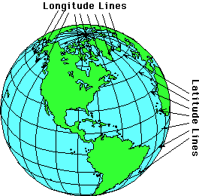
Background:
The Earth’s spin is used to define specific locations: the spin axis goes through the North and South Poles, and the equator is located midway between the poles. The Earth spins 360 degrees every 24 hours.

Latitude—Indicates how far north or south we are relative to a reference line of 0 degrees (°) at the equator. Latitude lines (also called parallels) are parallel to one another and range from 0° to 90°South at the South pole and 0° to 90°North at the North Pole.

Longitude—Indicates how far east or west we are relative to the 0° longitude line, known as the Prime Meridian, which runs through the Royal Observatory in Greenwich, England. Longitude lines (also called meridians) are perpendicular to latitude lines and extend from the North Pole to the South Pole. As Earth spins, longitude lines swing under the Sun like clock-work. Longitude lines are numbered from the Prime Meridian to 180° east of Greenwich and 180° west of Greenwich.

For specifying more precise locations, each degree of latitude or longitude is subdivided into 60 minutes of arc and each minute is further divided into 60 seconds of arc. An apostrophe (') is the symbol for minutes of arc, and a quotation mark (") is the symbol for seconds of arc. Example: San Francisco, California is 122° 26' W (west) of Greenwich and 37°46' N (north) of the equator.

Latitude and longitude are the foundation for the equatorial celestial coordinate system, which will be addressed in a later activity.

Note: You may be tempted to discuss the coordinate system based on altitude and azimuth, but this system is rarely used in astronomy because of its dependence on the observer’s horizon, which changes with their position on Earth (e.g., latitude and longitude) and the passage of time. The horizontal coordinate system (Alt/Az) also does not work at the North and South Poles since it is not possible to define an azimuth at either of these locations.

Performance notes
Students will use a web application to gather data. Following the activity, you may decide to assign students to record their own observations and make predictions of sun and moon positions over time.

Students could work on their own in groups. Have them choose cities with very different latitude and longitude locations. Before they begin, discuss with them how many data points they think they should gather in order to see a repeating pattern (hopefully they will converge on at least 12 readings/year, including summer/winter solstices and fall/spring equinoxes, for at least two years). Show them Suncalc and ask them what data from this app they think they should record on their data table (if they don’t bring it up, ask them about latitude, longitude, and positions of sunrise and sunset in degrees). Make sure students come to a consensus on the “zero point” of the horizon position angle that they will use in recording their data. Often, the zero point is 0° North, 90° East, 180° South, and 270° West, but other conventions are possible. It may be more intuitive to express the angle as degrees north or south of West for sunsets and north or south of East for sunrises. Have students graph their data in whatever way makes sense to them.

Example: Below are equinox and solstice data from Suncalc for several ‘Columbus locations’ from different states (Ohio, New Mexico, and North Dakota). You may choose to have students include data for other times of the year.
Columbus, OH: 39.97, 83.02 (latitude, longitude)
Mar 21 Sunrise 0 degrees east Sunset 0 degrees west
June 21 Sunrise 31 degrees northeast Sunset 31 degrees northwest
Sept 21 Sunrise 0 degrees east Sunset 0 degrees west
Dec 21 Sunrise 31 degrees southeast Sunset 30 degrees southwest
Columbus, NM: 31.89, 108.06
Mar 21 Sunrise 0 degrees east Sunset 0 degrees west
June 21 Sunrise 27 degrees northeast Sunset 28 degrees northwest
Sept 21 Sunrise 0 degrees east Sunset 0 degrees west
Dec 21 Sunrise 28 degrees southeast Sunset 26 degrees southwest
Columbus, ND: 48.98, 103.69
Mar 21 Sunrise 1 degrees northeast Sunset 1 degrees northwest
June 21 Sunrise 39 degrees northeast Sunset 38 degrees northwest
Sept 21 Sunrise 2 degrees southeast Sunset 2 degrees southwest
Dec 21 Sunrise 35 degrees southeast Sunset 34 degrees southwest

Post-activity discussion
Have the students whiteboard their conclusions and share. Look for agreement with connections to latitude and longitude and conclusions about how the sunrise, sunset (and possibly also midday) over the course of a year.
Did they attend to positions in terms of east/west?
Did they include latitude and longitude? Can they discern a pattern of sunrise/sunset times that is latitude/longitude dependent?

How do these positions relate to seasons?
How did pre-technology cultures collect the data they used to model the sun’s change in position over time (Stonehenge, etc)?
Are the models they constructed predictive?
Based on their data and representations, can they make predictions for dates in the future and then have them check their answers using the SunCalc. How many years should they collect data from to ensure their model is makes accurate predictions?

Extensions (and questions to ponder)
- Do we use time to measure space and if so, how? [This is a deep and abstract question.]
- Can this model be extended or a new model made for lunar phases? How would you set that up? What data would you collect to predict moon phases? How often would you need to make observations...what would be a good time interval between position measurements? What variables would you need to take into account? (examples: date, times of rise and set, amount illuminated.
- Students can make a Solar Motion Demonstrator that shows how the Sun moves in the sky and how that motion changes with season and latitude on Earth. The template is available under Classroom Activities for the planetarium show Stonehenge at https://sites.google.com/a/planetarium-activities.org/pass/shows/stonehenge?authuser=0
Apart from having students make daily observations over a period of time, other possible sources of data are:
- UNL NAAP Labs https://astro.unl.edu/nativeapps/NAAP_resources/ Basic Coordinates and Seasons has downloadable sims, a nice overview and a bit of history.
- MoonCalc - https://www.mooncalc.org — has it all.
- https://www.moonpage.com — for phase and illumination.
- https://www.timeanddate.com/moon/usa/time — also includes the rise and set time; uses Alt/Az system.
- Stellarium Web - https://stellarium-web.org/

2. Activity 2—Where is that dot in the sky? (Cosmic Directions for a Friend)

Note: the following activity requires advance planning. Clear evening skies for 2 nights (ideally 2 nights in a row) are necessary for students to complete it. The activity will take 3 days. On the first 2 days, very little time will be spent on it (day 1, set up and instructions for homework; day 2 trading the written directions students’ prepared for homework), but the third day will take the entire class period for whiteboarding and a board meeting.

This lab will help students to develop the beginnings of a system for mapping space and understanding celestial navigation and coordinates. Students will operationalize the concepts of cardinal directions and degrees as tools to use in giving and understanding celestial coordinates.

In the course of this lab, students will write step-by-step directions for a classmate to use to locate a celestial object they choose themselves. They will trade directions with another student and each student will try and locate their object based on the directions provided.

Groups will then whiteboard their model of celestial coordinates based on each other's work and ideas.
Materials (clear and accessible sky-best option, by far)
- Paper and writing utensil
- Clear sky and safe area at student’s home to view sky
- Flashlight [optional]
Materials (cloudy and/or inaccessible sky)
- Paper and writing utensil
- Smart phone with free night sky astronomy app
  - A computer may be used if necessary, but a smartphone is preferable. Have students use a family member’s smartphone if necessary.
  - https://www.hongkiat.com/blog/stargazing-apps/
Pre-lab discussion
Project an image of the night sky with the horizon in view (e.g. a Google image search of “night sky” gives plenty of usable results). Try and find an image with a few brighter objects/stars that would be easy to point to or circle in your slides. Have groups discuss how they might explain to someone elsewhere looking at the same image how to find a particular celestial object.

Procedure: Clear skies version
Students can use the drawing they made of the first night of class, or make a new one. They must choose a bright object (not the moon!) in their night sky that they can see clearly from home and make a rough sketch on paper of their viewing area horizon from wherever they are observing (e.g., their back or front yard). The sketch does not need to be detailed, but should have a few objects on the horizon (e.g. tree, parked car, neighbors house, or fence, etc). In the top part of the sketch the student should place (as accurately as possible) dots marking the positions of the bright objects he/she observes and he/she should circle the object that he/she wants his/her partner to find from their area.

The drawing must not put the name of the object if they know it. (If students want to give their own creative names to the object that they see they can, but they are not allowed to use any official names.)

On a separate sheet of paper, the student should write a detailed set of directions for their partner to use to find the object, knowing that their partner will have only these directions as a tool to find the object. The drawing must not be shared with the partner at this point in the exercise! This “finding chart” will be shared after their partner attempts to locate the object using the written directions.

Students will trade written directions with a classmate the next day. Partners will then use the written directions they receive to locate the object described from their home location that evening. They will make a sketch of the night sky in the direction of the object they are locating just as they did when they made their set of directions the previous night circling what they think is the target object they are supposed to find.

Cloudy skies version

If students have no safe access to somewhere to look at the night sky or there is unclear weather:
Students may use a night sky app on a smartphone if and only if they cannot view the sky from their location. Do your best to not make this an option as students will very likely choose this over naked eye observation, and it is not as effective. If they have to use a smartphone, they will still need to sketch the sky from their residence using paper and pencil as described above.

Using a smartphone, when students point the screen at the sky, the app will use GPS to determine the student’s location and show them the objects visible from their location. Students can use the image on their smartphone to help them pick their object and make their sketch, but they will still have to draw the horizon from their home location with labels as described in the directions above.
Post-lab discussion
Post-lab discussion
The next class period, partners will share their finding charts to see if they succeeded in finding the object their partner described for them. Then students will work together to whiteboard their approach to giving “cosmic” or “celestial” directions. These should include labeled drawings and coordinates. Whiteboards will then be shared with the class in a whole-group whiteboard-mediated discussion.

During the board meeting, guide students in reaching a consensus about the characteristics of a good system of quantifying an object’s position (cardinal directions and degrees at minimum) that will enable individuals to accurately identify the same object in space no matter where on earth each of them is standing. Another important element of their model that should emerge is how the hour at which they did their observation (e.g. 7 PM vs. 10 PM) affected the relative positions of objects in the night sky with respect to the horizon and compass directions. (This will not come up if everyone does their observations at the same hour.)

Angular separation may also arise naturally in this discussion. If there is time, it would be worth seeding this idea into the conversation, perhaps in the context of where the direction writer said the object was in the sky vs. where the observer thought the object was, or “how far” the object was from the moon or some other bright object. This discussion should set them up for upcoming activities that get them to RA and Dec.

Post-lab resources
- Cardinal Points for Celestial Observation

3. Activity 3—Where is that dot in the sky (part II)
By now, students should have been refining their map of space around Earth to include at least cardinal directions and degrees, and possibly latitude and longitude. In this next lab, students will further develop their understanding of celestial navigation and coordinates by operationalizing the concepts of right ascension and declination.

In this lab, students will begin by recalling how to best give coordinates for any spot on the spherical Earth (latitude and longitude). Subsequently, they will project this coordinate system out into space and use it to locate objects in space around Earth.

An optional post-lab reading will be offered to learn about how slaves in the U.S. used celestial navigation to find their way through the underground railroad. At the conclusion of the lab, groups will whiteboard their revised celestial coordinate systems.

Materials
- Earth globe for each group
- Celestial sphere for each group
  - An inexpensive option is available from Science First’s Starlab: https://shop.sciencefirst.com/starlab/kits/5802-celestial-sphere-single.html
  - Another option is to make your own by using DIY Christmas “clear open ball ornaments”, or other craft materials (see below for example)
  - Lastly, you could try and find some 3D images of celestial spheres with little to no markings so you can add a different dots to printouts for each group, but having the physical model is the best option!
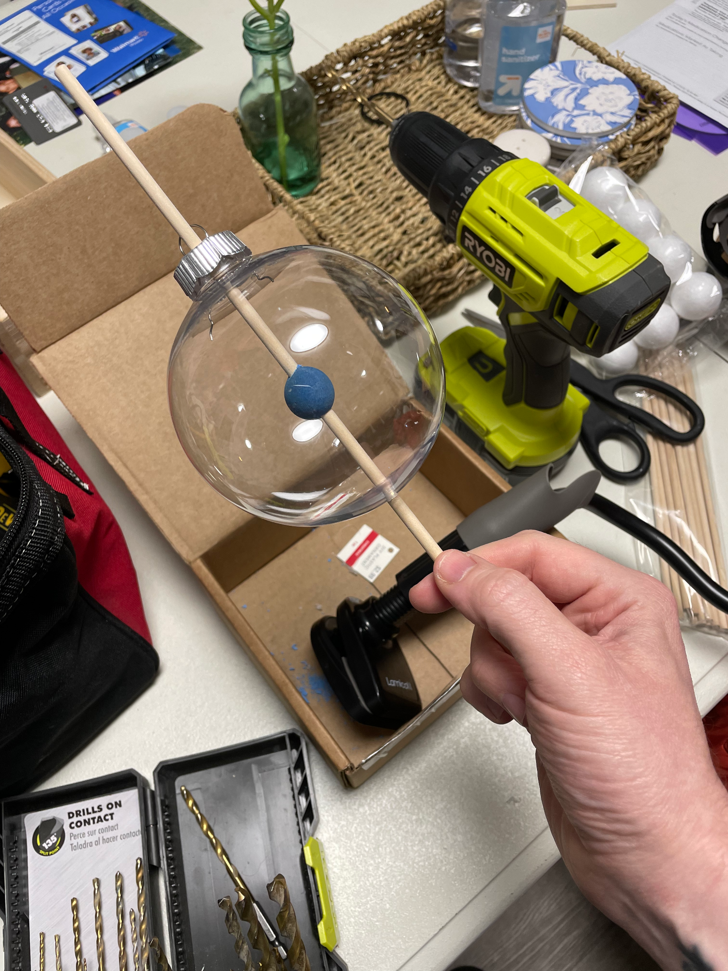

Pre-Lab Discussion
Ask students to recall their models from the “Cosmic Directions for a Friend” lab. What worked well in their models, what did not?

Then, show students an image on the projector of an exoplanet (note there are not any good images of exoplanets available yet, but there are plenty of artist interpretations you can find on a google search). Have them imagine that the human species has advanced in space travel so that we are now capable of space travel to this exoplanet.

The coordinate system they used for “Cosmic Directions for a Friend” may have worked okay for their friends in the same neighborhood or town, but will these work to give directions to some exoplanet from anywhere on Earth? Would they be sufficient for a serious interstellar travel plan by future explorers?

Procedure
The lab consists of two parts, with the first part using the Earth only globe, then the second part using the celestial sphere globe with Earth in the center of a clear sphere.

Earth only globe
Using a sticker, or tape, or an erasable marker, place a small dot on a different spot for each group’s globe and place it on each group’s table. Ask students to develop a method in their groups that would adequately allow them to give coordinates for their spot on the globe. Their method should also be useful for other groups’ spots. This should be a short and kind of introductory portion of their lab to help them remember latitude and longitude.

Celestial sphere globe
Teachers should follow the exact same directions as for the Earth only globe, except placing the dot on the clear celestial sphere. Students should be asked to refine their method to now give coordinates for the spot on their celestial sphere. Can they use the same system? Why or why not?

Post-lab discussion
During the board meeting, guide students in reaching a consensus about the characteristics of a good system of measurement that will enable individuals to accurately identify the same celestial object in space no matter where on earth each of them is standing. Another important element of their system of measurement that should emerge (as it did in “Cosmic Directions for a Friend”) is how the hour at which an observation is made (e.g. 7 PM vs. 10 PM) affects the relative positions of objects in the night sky with respect to the horizon according to their relative position.

- Did students determine some aspect of their system that would give a reference point on the celestial sphere?
- Were there any similarities to latitude and longitude that were used in the celestial sphere model?
- How does their coordinate system account for a moving and rotating Earth revolving around the Sun?
- What can students agree on for the necessary characteristics of a “universal” system for celestial coordinates for their future space explorers to exoplanets?
- Are students remembering to record not just “where,” but “when” a measurement is taken?

Post-lab activities and additional resources
- The Celestial Sphere by Planetary Science dot org
- University of Oregon Celestial Coordinate System: http://homework.uoregon.edu/pub/emj/121/lectures/skycoords.html
- How To Find North, East Or Any Other Direction By Watching the Sky
  - What will you do to find your way around during the zombie apocalypse
- A century of astronomy revealed Earth’s place in the universe
- Astronomy Education at the University of Nebraska-Lincoln Astronomy Interactive Simulators (requires install on student computer, but has many valuable simulators, such as for the celestial sphere): https://astro.unl.edu/interactives/ . Check out the sun simulator in the NAAP Labs Orbits and Lights, and all the simulators in Basic Coordinates and Seasons.

4. Activity 4—Discovering Celestial Objects

This activity is meant to give students an introduction to astronomy image analysis software, SalsaJ or JS9. Students will be introduced to various celestial objects and they will open them in the image software and try to determine what the objects are. It should build on the students’ existing model of appearances and names of astronomical objects beyond the moon and sun. Of equal importance, it sets an expectation that the students will be doing astronomy throughout the course.

Time spent on this activity should not be excessive and do not worry need not name objects or come to exact agreements on what objects are. They will simply develop a system for grouping or categorizing celestial objects.

Apparatus
- Digital images for SalsaJ/JS9 practice (set of 14): “U1Act4 Intro Astro Images for Practice” (folder)
  - Within the “U1 Images AME2022” folder”
- Teacher and student computers
- Projector
- For each lab group, one set of 2" by 3" printed black and white images of images for categorization (folder of images is “U1Act4 Images for Categorization”—May be printed on cardstock for reusability).

First: Students use image processing (IP) software (SalsaJ or JS9) to view images in “U1Act4 Intro Astro Images for Practice” folder for an introduction to the software and various astronomical images.

SalsaJ is designed for use on local computers and JS9 for use in browsers.
- If using SalsaJ, preload the program onto student computers.
- For either SalsaJ or JS9 software, preload onto the computers both sets of images: teacher set of 14 (“U1Act4 Intro Astro Images for Practice”) and student set of 16 (“U1Act4 Images for Categorization”) in separate folders.
- If you decide to use SalsaJ or JS9 with this activity, review how to load and magnify the images before class, and test the student versions of SalsaJ and the images before class.
- See the videos in the folder “SalsaJ How to Videos” if you need a review on these SalsaJ tools.

Pre-activity discussion
Project the images one by one by opening them in SalsaJ.

As students see each image, encourage them to make suggestions about what the object is and what they know about it in their groups. Do not spend a long time discussing each image. The goal is for students to develop operational definitions (simple description of only a few words) they can use to categorize images. Sample definitions are listed below. Note that Image 13 and 14 are of exoplanets and they should be revisited at some point before the end of the activity for further discussion. At that point you may want to reveal what they actually are and share some of additional info in the hyperlinks below.
Image 1-Asteroid: Boulder-like object
Image 2-Comet: Object that has a tail
Image 3-Crater: result of an impact
Image 4-Eclipse: When the Moon blocks the Sun
Image 5-Galaxy: A huge collection of stars
Image 6-Globular cluster: A dense collection of stars
Image 7-Moon: object that goes around a planet
Image 8-Nebula: A cloud in space
Image 9-Open cluster: A diffuse collection of stars
Image 10-Moon Phase: Sunlight on the Moon
Image 11-Planet: Orbits the Sun
Image 12-Star: A burning ball of gas
Image 13-Exoplanet: ripple in a pond with bright star/dot
→ Animation of real footage of Beta Pictoris b orbiting its star from SETI site
Image 14-Exoplanets: Sunlike object with orbiting bright dots
→ Background information on “Image 13” about first direct image of exoplanet around sunlike star

Performance notes
Distribute printed image sets (“U1Act4 Images for Categorization” with image number) to each group of students; and have them develop within their small group a categorization scheme tht makes sense to them and then classify each of the images. Some images may fit more than one category--if so, they should make a note of this. Have them whiteboard their results (they could affix small images to their whiteboards in the categories they decide they belong to).

Post-activity discussion
In a post-activity whiteboard meeting, focus on students’ rationale for the categorization scheme they developed.

U1Act4 Images for Categorization (Image Set 2). The descriptions below are what the images actually are. We expect students to produce a set of categories to which the images belong that they can justify inclusion of each image into their self-created categories.
Image 13: globular star cluster  Image 14: planet  Image 15: Moon  Image 16: nebula  Image 17: galaxies  Image 18: comet  Image 19: galaxies  Image 20: eclipse  Image 21: craters | Image 22: asteroid  Image 23: star cluster  Image 24: exoplanet and star  Image 25: stars  Image 26: Moon during eclipse  Image 27: system of exoplanets  Image 28: star  Image 29: nebula  Image 30: galaxies

Post activity extensions: Ask students if they have seen or read stories about celestial objects in the news and on the Internet. Have students share some of the things they have seen recently. Tell them that there are new developments in astronomy often breaking in the news.

Ask (or perhaps assign) them to look for such articles and news stories. Consider starting a bulletin board where stories can be posted and ask students who contribute articles to tell the class about them. Students can write excerpts or summaries of articles in their notebooks. This can be an ongoing class activity that makes the course come alive in terms of current events.

An example of an online bulletin board where articles are posted can be found on the Global Systems Science website - http://www.globalsystemsscience.org/uptodate/acc - where each of the nine chapters of the online book A Changing Cosmos has collections of excerpts of articles with links to the original articles.

Create a Scale Model of the Solar System

5. Worksheet 1 - Cosmic Units & Conversions
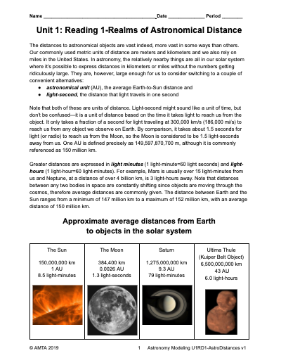
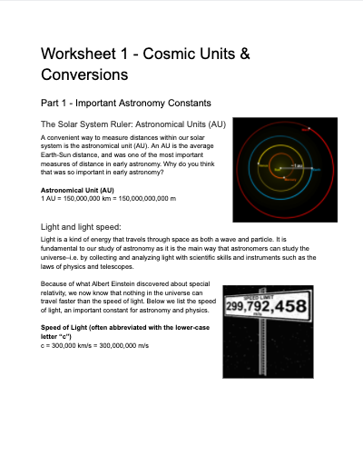

6. Reading 1—Realms of Astronomical Distance

In their current measurement model, students have been taught metric units based on the meter (centimeter, kilometer), but they most likely rely on the familiar units of the US Customary system -- inch, foot, yard, and mile. These units are woefully inadequate for the vast distances in astronomy, particularly when we move outside the realm of our Sun-Moon-Earth system.

This reading introduces students to two alternative units of distance (1) astronomical unit (AU) which is the average Earth-to-Sun distance, and (2) the light-second, the distance that light travels in one second. It is important that students understand that while the light-second may sound like a unit of time, it is a unit of distance based on the time it takes light to reach us from the object. We haven’t discussed electromagnetic radiation yet, so teachers may want to avoid distinguishing between light waves and radio waves.

The reading presents images and distances for objects within our solar system, outside the solar system but within the Milky Way galaxy, and outside our galaxy. The images reinforce the operational definitions students created in Activity 3.

7. Activity 5 - Locating Events in Spacetime

Where/when did that happen?

The following activity is designed to help students understand time as a dimension of spacetime. An instant in time is a one spacetime coordinate that, taken together with a event’s location in x-y-z space, provides the invariant location of an event, e.g., the location of an exoplanet at the moment it begins to transit, the location of the sun at the instant it crosses the horizon, the location of a mic drop on a concert stage. To do this, we must add a t-coordinate to our familiar x, y and z spatial coordinate system. This t-coordinate can be expressed as a distance or length (just like x, y and z): it is the distance light travels during some time interval, Δt. We convert time to length by multiplying it by the constant, c, the speed of light. We can, of course, also convert length to time by dividing it by c. allowing us to express all four dimensions of spacetime as ‘space-like’ or ‘time-like’ dimensions.

Pre-activity discussion:

What is an event? Before you begin this activity you will need to have students brainstorm to come up with a consensus definition of the word “event” that specifies what it is, and when and where it happens. Do this as a whole group. Ask students what is needed for a definition of this term in order to use it in a scientific context.

Activity:
Part 1: When and where?
Once you have a definition that includes its location in space and time, show students images of a transiting object (such as Venus, Mercury, a Jovian moon or an exoplanet) and then give them the light curve or light curve data table produced by this transit. Ask them to come to decide what “events” (instants in space and time) associated with this phenomenon are important/interesting/worthy of note. (They should at least identify the beginning of the transit and the end of the transit. They may also mention mid transit.) Let them work on this in small groups and report their consensus back to the whole group.

Breakout group activity 1:
After they have reached an agreement on this, ask when and where this transit happened. (They should be able to read a time off the graph or data table you have given them, and they should be provided with some basic info about the object being transited--its name, its type, how far away it is). Ask them to be specific: Is that Pacific Standard Time? Eastern Standard Time? Australian Standard Time? Do we know? How do we account for the fact that earthbound observers may be observing an “event” from different time zones? Give them time to arrive at an answer in their small groups and report their consensus back to the whole group. (Whole group discussion should lead to GMT or ‘UTC’--a system used by astronomers, coordinated universal time.)

Breakout group activity 2:
Next, ask: how do you know that these events happened? (Presumably you will hear, “We saw it” or “our telescopes or cameras saw it.”) Press them to define what we mean when we say “seeing?” How do our eyes or our telescopes “see” an event? What is the mechanism we call seeing? (Light travels from the star until it hits a detector or our eye.) Light from where? (From the star being transited.) Does light do that trip instantaneously or does it travel at a finite speed? Have them return to small groups again to refine their description of when the transit happened. When they are done, let them share their refinements.

Breakout group activity 3
Next, present the following scenario: there is a person on that planet whose clock is (miraculously) synchronized with earth clocks and who can see Earth. Therefore she can calculate exactly when her exoplanet starts and finishes it’s transit from Earth’s perspective. Would that person agree with you about the transit ingress and egress times as shown on your clock is when those events actually took place? This discussion should uncover the fact that it took some interval of time for light from the star being transited to reach our telescope, so the event did not happen at the same time for her as we recorded it in Earth time.

So how do we know when? Remember, a light year is a measure of an interval of space--a distance. Measuring distance requires us to know two points--a starting and an ending point. Have students work in small groups to determine corresponding pairs of points in time that they can associate with the beginning and end of two transits that will happen soon.

HD189733 b (distance to Earth: 63.6 ly) is a good candidate for this exercise but you can pick others at this website: https://astro.swarthmore.edu/transits/transits.cgi. To find transits that will happen soon, you can pick an observatory close to you from the dropdown list (or elsewhere in the world if you like). To begin with, in the date window choose “today” as the start of your list and “3 days” as the time interval (this should be the default). Click “submit.” There will likely be a several second delay while the list is generated, and you will see it is quite large. To narrow your search you can scroll down to the field entitled “Name:” which lets you enter a string that must be included in the data row. Enter “WASP” (Hide Angle Search for Planets) or “HD” (Henry Draper) or “HAT” (Hungarian-made Automated Telescope Network) here and you will get a list that only includes exoplanets with those designations. Of course you can choose other transits for them to calculate from the list generated if you like. You can look up the distance to the star being orbited on the web. If you are not finding the object you want in the list the website offers, you can broaden your search by checking the box “Space observing” or enlarging the date range, or both.

The table generated when you click “submit” will show you lots of information about the upcoming transit. Of interest to your students will be the date, start, mid and end times for the transit. Be aware that unless you set it up to show transit times in UTC they will be shown in local observatory time.

You can either get the information they need for this exercise for your students in advance, or depending on how much time you have, let them retrieve it themselves from the Swarthmore website. It’s an interesting opportunity for them to see just how many objects can be seen on a typical evening from a particular location on the earth. (The table shows you lots of other interesting information that is relevant to observing transits, such as magnitude and transit depth which refers to the degree of dimming of the star as the planet passes in front of it. It is difficult to observe transits from ground based telescopes unless they have a depth of more than 1%.)

Give students time in small groups to determine when the transits will happen/did happen for the Earthbound observer and for the observer located on the exoplanet. Then let them share data and come to an agreement on correct values.

Our two observations of the transit--beginning and end--happened at the same place (assuming we didn’t move our telescope in the interval between ingress and egress) but at different times. This is true also for our imaginary observer on the transiting planet. (let’s assume she stayed put also, and did not move her telescope during the transit). What transit measurements would she agree with you on? What measurements would she differ with?

Breakout group session 4
What about a person on a spaceship traveling at .5c away from earth and toward the transiting exoplanet? Does light from the target star reach the spaceship at the same time it reaches us? Sooner? Later? Would the space traveler measure a transit of the same duration as we measure on Earth (or as our imaginary observer friends on the transiting planet)? Would the space traveler think the transit takes more time? Less time? Have students discuss this in small groups and see if they can represent their conclusion in a diagram or series of diagrams that compare the 3 observers observation results.

When they come back together and discuss their conclusions they will hopefully agree that for the space traveler less time will have passed. How can this be?

This paradox introduces the notion of relativity--the relativity of simultaneity. People moving at different speeds do not agree on intervals of length and time, but they do agree on intervals of spacetime.

Since for two observers moving at different velocities, events are distant from one another in space and time we need to specify an absolute interval between two events, we must convert time to spatial dimension using a constant, the speed of light, as a conversion factor: Δx = cΔt where Δx is an interval of space, Δt is an interval of time and c is the speed of light. Only then can you determine whether events are “simultaneous.”

Part 2: Simultaneity

How can you know that 2 events are simultaneous?

Imagine three physicists, Colleen, Dan and Earl are on Zoom together with their cameras on. Each one has a highly accurate light detecting ‘nanosecond clock’ and these clocks are synchronized. Colleen in Sacramento. Dan is in the San Francisco Bay area 100 miles away. Earl is in Colorado 1000 miles away. Colleen asks them to tell her their exact clock reading on their respective clocks when she clicks off her light.
Breakout group session 1
In small groups decide:
What does Earl’s clock read?
What does Dan’s clock read?
What assumption(s) did you have to make to produce these answers? (Hopefully they will be able to say that the signals to the two observers travelled at the same speed, and that this speed was the speed of light.)

Next, consider the sunset. We can come up with an exact moment at which the sun disappears over the horizon, but is that actually the instant that it happened? What time did the sun actually set?

What other examples of this phenomenon can you come up with?

Part 3:Spacetime diagrams
Spacetime diagrams are used to plot objects’ relative positions in space and time.
One dimension of space: Two dimensions of space:

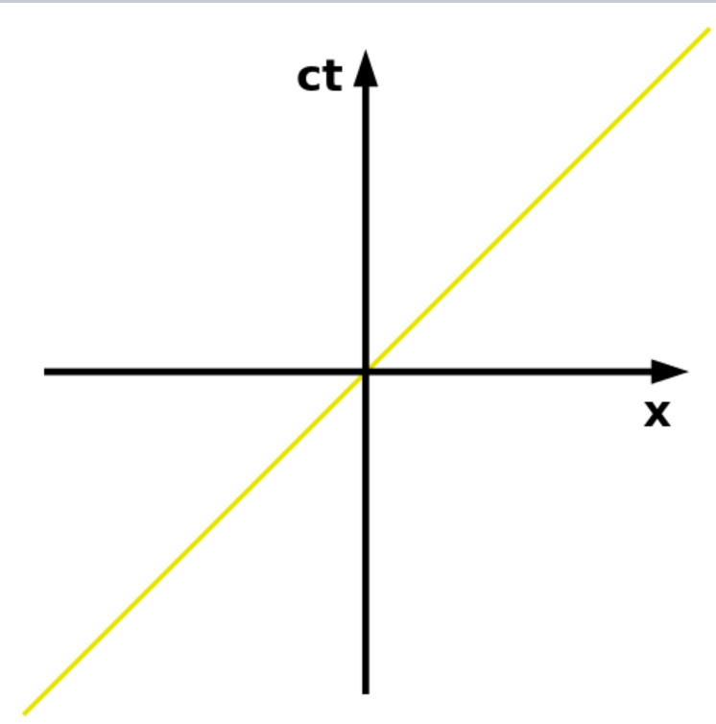

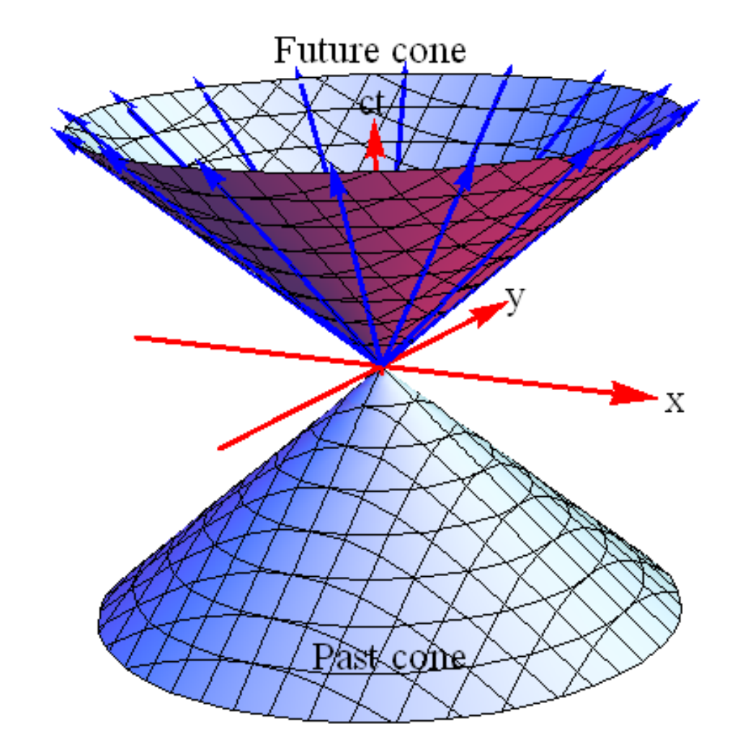

For simplicity we will just use a one dimensional plot.

To begin with, just put time (t) in seconds on the vertical axis, and plot the positions of you and your dog, Max. You have told Max to “sit” and “stay.” Max does as he is told. Place Max at the origin and plot your initial position at 1 m to the right of Max. After both you and Max being stationary for 3 seconds, you begin to walk away from Max at a speed of 0.5 m/s for 10 s. Max obediently remains. You come to a stop at 10 s, remain stopped for 5 seconds and then you walk back toward Max at a speed of 1 m/s, stopping at your original starting position. Plot this journey on your spacetime diagram. When you connect the dots you have placed, the picture you get is called a worldline.

Now redraw this spacetime diagram from your perspective. Place yourself at the origin and Max one meter to the left of the origin. How would Max’s position change (with respect to you) over the next 20 seconds. Draw Max’s worldline using your location as the stationary reference frame.

Optional: If your students really want to dig into spacetime physics here is a good series of videos
What is special relativity (Chapter 1, Minute Physics)
https://www.youtube.com/watch?v=1rLWVZVWfdY
(check out the cool spacetime “machine”--a time globe--that he’s made and shows at the end of this video. We need to figure out how to make one of these!)

Spacetime diagrams video (Chapter 2, Minute Physics)
https://www.youtube.com/watch?v=hTxWAQGgeQw

(Chapter 3, Minute Physics)
https://www.youtube.com/watch?v=Rh0pYtQG5wI
A nice visual of Lorentzian geometry that shows why the speed of light is constant in all reference frames...he uses the time globe extensively in this video.

Time dilation: (somewhat advanced)
https://www.youtube.com/watch?v=5qQheJn-FHc

8. Worksheet 2 - Same Event According to Observers in Different Reference Frames
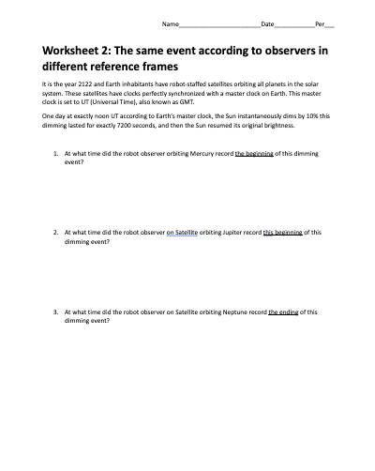

9. Activity 6—How do we know the objects are out there?

Almost everything we see that is not a star or a light bulb (or other light emitting source like flames, backlit displays, etc.), we see only because light from a star (our Sun) or light from another light source scatters off of the object. So most of our outdoor daytime vision is due to light from a star (nice, eh?) . In addition, many astronomical objects shine because of scattered light from a star or stars. For example, the blue and red colors of the Orion Nebula occur because interstellar dust and gas in the nebula scatters light from nearby or embedded stars. Nebular spectral lines (OIII and H-alpha) are caused by electrons excited by photons from nearby stars.

The purpose of the lab is to help students create a model for understanding the behavior of light that will be fundamental to this course. Namely, how light travels in a straight line, how it can scatter off of objects, and eventually end up in a detector or our eye. Although these experiments may seem simplistic, many students think that we “see” by sending out some sort of active signal (fondly called “bat vision”) that can then detect an object. Superman’s X-ray vision lends support to this misconception. Plato subscribed to this primitive model of light too, so students are in good company.

Apparatus
- laser pointer with reasonable power (5mW should be sufficient)
- Classroom wall

Whiteboards

Mix a few drops of milk into 2 or 3 oz of water and put it into a plastic spray bottle,

A dark room

Pre-activity discussion
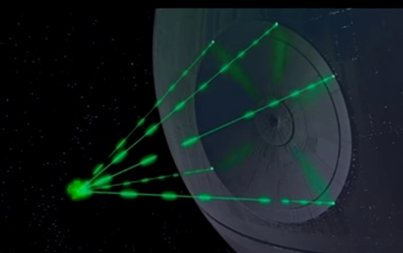
Students may be familiar with laser rays from depictions in movies such as the destruction of the planet Aldreraan in “Star Wars: Episode IV-A New Hope”.(show this videoclip if they need a refresher: https://www.youtube.com/watch?v=7g77WN6obk4&disable_polymer=true).

In the movie, a beam of light fired from the Death Star destroys an entire planet. Project the image at right of the Death Star (U1Act4_DeathStar) and the beams of light and ask students to describe what they are seeing.

Write short versions of their answers on the board. Eventually they should converge on the idea that the beams of light are some sort of laser. Call the rays “laser rays” for clarity.

Show students the laser pointer. Ask them what it does, without saying anything about the beam or their eyes. Most students probably know from science fiction that a laser emits a straight ray or line segment of light. But understanding in detail how we see the light is not well developed and there are some beautiful subtleties that many students would not usually predict.

Ask the students to imagine that they are looking down on the classroom from above. Ask them to make a quick sketch of what this would look like in their notebook, or have someone come to the front of the room and draw it on the board. In their drawings, they should include the teacher, the walls of the room, and their desks (at least say, six or seven 3-person teams positions, scattered around the room, as viewed from a viewing point maybe ten yards above the room).

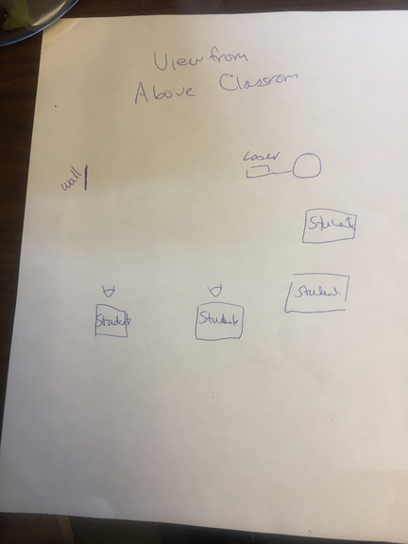
At right is a typical example of a student diagram - a top view of the room, as if they are above the ceiling.

Tell students that they are going to consider four scenarios involving the laser and the line segment of light it creates. They will sketch each situation as if viewing from above using the diagram of the room and desks as a base.

Performance notes
Scenario 1: Laser pointing out of the open door of the classroom (or into a box).
- Tell students you are going to point the laser out the open door of the classroom (or into a box). Note:You are doing this so students cannot see the scattered beam, but don’t tell them this.
- Ask students to predict what they would see if they were viewing this scenario from above. Record their responses on the board either in words or sketches, or have them quickly sketch their responses in their notebooks on a whiteboard.
- To perform the experiment, shine the beam on your hand to show students that the laser is on. While it is on, pull your hand away and point the laser out of the open door of the room. Remind students that the laser is still on, but it is pointing out of the room.
- Discuss what they observed and allow them to modify their predicted representations if necessary.

Scenario 2: Laser crossing the room as a volunteer student mists the path.
- Tell the students you are going to point the laser across the room, and a volunteer student will spray a mist of milk and water at various places along the laser beam. As before, ask them what they think they will see, and have them draw the path (as if looking from above) of the light ray, which may or may not end up in their eyes.
- Do the experiment, discuss what they saw, and have the students modify their representation if necessary.

Scenario 3: Laser crossing the room, hitting the wall and scattering.
- Tell the students you are going to point the laser across the room at a white wall (not a mirror), and ask students what they would see if they could see the path of the light to their eyes. Have them draw in potential paths to their own eye and to other students in the room, and ask them to draw the path of light to those other students, if it would get to them.
- Do the experiment, discuss their drawings, and have the students modify their drawings as needed.

Scenario 4: Laser crossing the darkened room with everybody standing near the scattering wall where mists will be sprayed.
- Tell the students you are going to point the laser across the darkened room at the white wall (not a mirror), and a volunteer student will spray mist into the air near the wall. Ask students to sketch what they would expect to see and what the path of the light would be to their eyes.
- Do the experiment. If the room is sufficiently dark and the laser sufficiently bright you will see a very beautiful spherical halo around and radiating outwards from the wall.
- Ask the students to make a diagrammatic representation of the scattering of the laser off the walls and off the particles of mist. Ask them to describe it in words (no pictures!) what they saw.

Post-activity discussion
Have the students consider the question: How do we know that objects are out in space? They should articulate the notion that light from the object (either emitted or reflected) carries this information. Light travels in straight (-ish) lines (we don’t want to talk about curved space here).
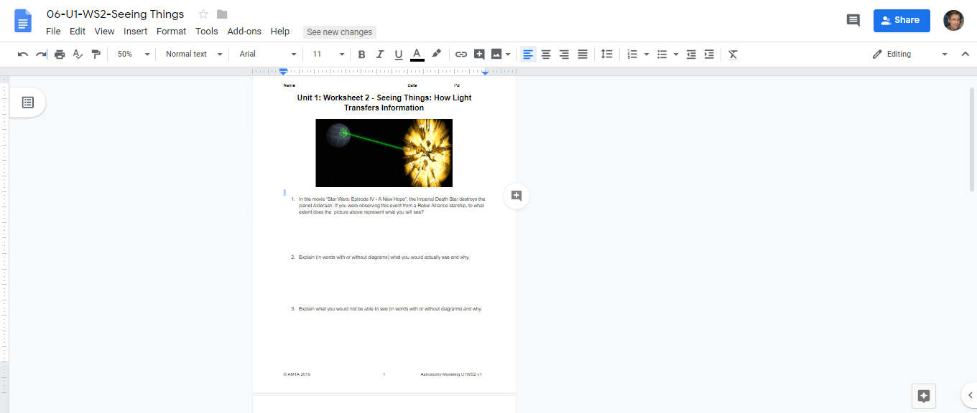
When the light hits a surface, it scatters in every direction, and when it hits a detector (in this case, their eye) the detector translates this light into an image. Finally ask the students if they see anything wrong or scientifically inaccurate about the picture of the Star Wars Death Star planet-destroying weapon. This leads to Worksheet 2.

10. Worksheet 3—Seeing Things-How Light Transfers Information

In Worksheet 2 students use what they have learned about the dispersion of light to critique how the destruction of the planet Alderaan by the Death Star was shown in “Star Wars: Episode IV - A New Hope” and to explain things they can see, like a tree or the Moon and its phases.

11. Activity 7—Locate the Trappist-1 Exoplanet System

In Activity 1 and 2, we used degrees of latitude and longitude to identify the position of the Sun and Moon on the horizon and began to develop an understanding of how to find objects in space using right ascension (RA) and declination (Dec). In this activity, we will further develop our model--map of space around Earth--to identify the location of a famous exoplanet system, called TRAPPIST-1, using the celestial coordinate system (RA and Dec). It may help to remind students that RA/Dec is similar to the geographic coordinate system (longitude and latitude, respectively) we use on Earth.

Apparatus
- A Star Wheel for each student (“Uncle Al’s Star Wheel”)
Plan on either giving each student a Star Wheel to keep or making a class set for students to use, but not keep. If the latter, consider photocopying the master (U1-Act9-StarwheelN.pdf) on cardstock and/or laminating them. Yet another strategy is to do both, have students use a class set to not waste time making them in class, but give each student a copy to make their own outside of class.
- Optional: Globe

Pre-activity discussion
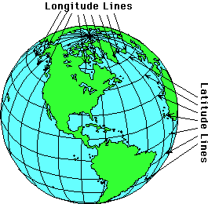
Ask students to recall “How do we specify an exact location on the Earth?” (from Activity 1):

Latitude—how far north or south we are on Earth, the equator being 0° latitude, the South Pole 90°S and the North Pole 90°North.
Longitude—how far east or west we are from the Prime Meridian (0° longitude) that goes through Greenwich, England. Longitude lines go to 180 degrees east of Greenwich and 180 degrees west of Greenwich.

Ask “Do you think there is a comparable way to specify exactly where an object is in the sky?”

Lead the discussion to the idea that celestial coordinates are to the sky as geographical coordinates (latitude and longitude) are to the Earth. Tell them that ancient civilizations believed that there was a giant celestial sphere to which celestial objects were attached. Have them imagine extending the Earth’s axis infinitely into space. It would pierce that celestial sphere in two places: the celestial north pole and the celestial south pole. Similarly, imagine Earth’s equator being extended infinitely outward to the celestial sphere becoming the celestial equator.
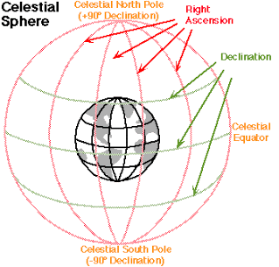
Show the diagram below. Or open NAAP Labs Basic Coordinates and Seasons unit and show them the Celestial Equatorial Coordinate System sim. Even though we know there is no physical sphere holding up the stars, we find it convenient to think of an imaginary celestial sphere to specify locations of cosmic objects. Define and name the components of the celestial coordinate system (Right Ascension and Declination):
Declination (dec) is the celestial coordinate corresponding to latitude. As with latitude on Earth, declination in the sky increases from 0° at the celestial equator to 90° at the celestial North Pole and -90° at the celestial South pole. As with latitude on Earth, each degree is divided into 60 minute divisions (') and each minute is further divided into 60 seconds ("). To distinguish units of minutes and seconds between clock time and angular measurement, the angular units are referred to as arcminutes and arcseconds. But they use the same symbols as minutes (') and seconds ("), e.g. 40 arcminutes = 40', 25 arcseconds = 25". Note that degrees of declination are NOT referred to as arcdegrees.

Right Ascension (RA) is the name of the celestial coordinate that corresponds to longitude on Earth. Unlike longitude, which is measured in degrees and minutes, right ascension is measured in hours and minutes. This comes from the fact that standing here on Earth which is rotating, we see everything in the sky wheeling around us once every 24 hours. So there are 24 hours of right ascension corresponding to the length of time for one rotation of Earth. As you might expect by now, each hour has 60 minute divisions (') and each minute is further divided into 60 seconds (").

Tell students they will make a model that can specify positions of extraterrestrial objects and even show the motion of the cosmos—how it changes hour by hour, month by month.

Performance notes
- Hand out “Uncle Al's HOU Sky Wheel”. If you decide students should make theirs in class, follow the instructions on the printed starwheel sheet. There are two wheels. Use the one with the celestial coordinate system on it (labeled grid version in instructions).
- Ask students to identify the two components of this model. [star wheel and the star wheel holder] Direct their attention to some of its characteristics.
  - We call the point straight overhead in the sky the zenith. Where is that on your Star Wheel? [Answer: Center.]
  - What constellation is located at (approximately) the zenith on the Star Wheel? [Ursa Minor]
  - Notice where the values of declination (dec) are shown on the Star Wheel. [Along the lines running toward the center from 0 hours to 23 hours 59 minutes. The 0/24 hour mark starts around March 23] Can you determine the precision of the scale? [each line counts up by 10 min, thus between 0 and 1 there are 6 increments or 60 min]
  - Notice where the values of right ascension (RA) are shown on the Star Wheel? [on the outermost circle inside the days of each month] What is the precision of the scale? [10 min, 10’] What are the minimum and maximum values [0 and 23]
  - How many degrees does the sky shift in one hour? [Answer: 360°/24 hours = 15°/h or 180°/12 h = 15°/h]
- Have students examine the second part of the model, the Star Wheel holder. Direct their attention to its markings.
  - Notice the word horizon for each of the cardinal directions on the Star Wheel Holder--what do you think this means? [Answer: Edge of the starwheel window for that direction.]
  - Times on the Star Wheel Holder are for standard time, how would you compensate when your clock is set to daylight savings time? [Answer: Subtract an hour in setting the time on the starwheel]
  - Why do you suppose the holder is labeled “Northern Hemisphere”? How do you think a holder for the Southern Hemisphere would be different? Would a Star Wheel for the Southern Hemisphere be different? Why or why not?
- That this tool can represent the sky anytime of night, any day of the year. Have them figure out how to set the starwheel for today’s date. Remind them to read the instructions on the back of the holder before they begin using it with the Star Wheel.
  - This YouTube video, “Using a Star Wheel”, may help: https://youtu.be/TlcRGWctPvQ
  - Ask them to locate the constellation Cygnus on their Star Wheel. They will observe that it consists of at least 8 stars. Ask them to identify the rough coordinates (RA and Dec) of the constellation using the center star of its “cross pattern”. [Cygnus coordinates answer: RA 20h 15m and dec +42°]. This constellation contains many exoplanets discovered by the Kepler Space Telescope, such as Kepler-186f. Show them The Quest for Another Earth video after they find Cygnus and then see if they make the connection that the video states that Kepler-186f is located within Cygnus. Have a quick discussion about exoplanets and how exciting it is that they can now find this exoplanet and show their friends and family where an “Earth-like” planet is in the sky!
    - The Quest for Another Earth video (for Kepler-186f): https://youtu.be/X9GCrtIM7D8
  - Show them this video by Physics Girl introducing the TRAPPIST-1 exoplanet system: https://youtu.be/lK2iJe7AM_Q
    - Ask what they found interesting about the video
    - Have them locate TRAPPIST-1 on the star wheels. Don’t give them the constellation it is in--let them figure it out themselves by doing a little research (hint: the Wikipedia page tells you it is in Aquarius so it shouldn’t be too hard for them to find out).
    - Have them find the constellation Aquarius/TRAPPIST-1 on their Star Wheel. They will observe that it consists of at least 9 stars. Ask them to identify the coordinates (RA and dec) of the star that is second from the left of the A in the word AQUARIUS (circled in red in diagram below). [Approximate star wheel answer: RA 22h 53m dec -07°]. [Exact answer for TRAPPIST-1 coordinates: RA 23h 06m and dec -05° 02’]
      - Note: getting close to these coordinates is fine as it will be very difficult to get the exact answer since there isn’t a good marker on the star wheel for TRAPPIST-1, but you could always add one in your prints (maybe a smiley face or circle for exoplanet)!
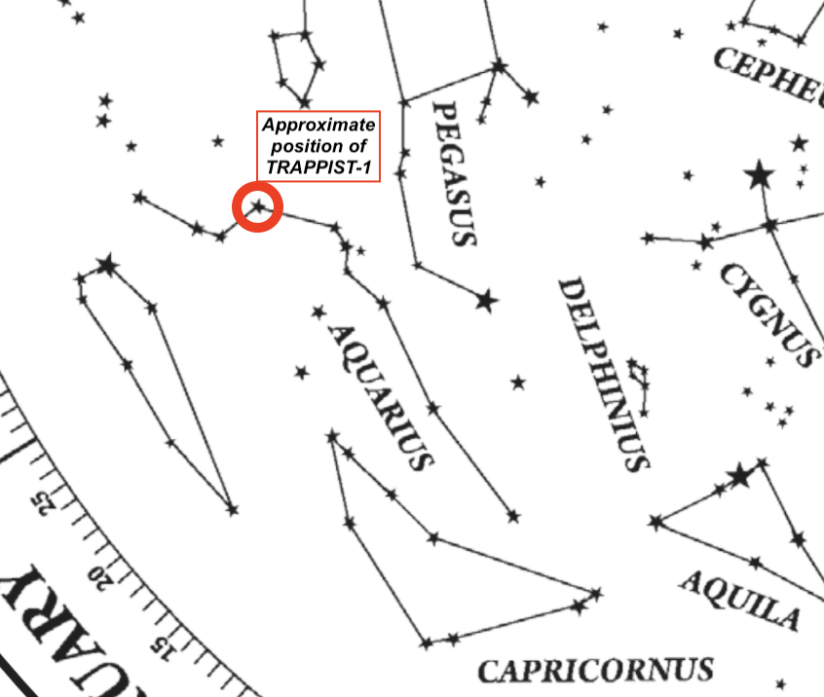

  - Ask, “What would be the best times to observe the TRAPPIST-1 system?” [Using the star wheel, set it for when Aquarius is as far from the “horizon line” as possible so it is as “high in the sky” as possible. If you want to view early in the evening, the best dates/times are late August through early November with viewing times ranging from 7 pm to 12 am. From early June to late August you would have to observe between 12 am and 6 am. Note you can turn the wheel so Aquarius is still in the window and viewable for other dates/times and this could be practiced too.]. Ask them to explain how they determined their answer.

Optional Zodiac and Horoscope Discussions/Activity
- Discussion on Zodiac: Aquarius is one of the Zodiac constellations. Many students will be excited about asking each other what their “sign” is and it is unlikely that you will not hear these conversations. This may be a good time to discuss what the Zodiac is. You may ask them, ‘What month do you have to be born to be an Aquarius?’ and since most will say January/February, you could ask them to then explain why Aquarius is not observed in January/February. [Zodiac constellations are determined by when the constellation is directly behind the Sun at that particularly date, which is why you cannot see it at its respective date]
- Discussion on Zodiac part 2: Encourage students to discuss what their Zodiac signs are based on their birth. Give them a table based on the one on the below website, but exclude the traditional dates so it only shows the actual dates. Students will be very surprised and may not believe what you are showing them. This is a great lesson on how science works and how it encourages us to question everything.
https://skyandtelescope.org/astronomy-news/observing-news/a-sign-of-the-times/
Activity
- Activity Idea: Teach students how the Zodiac signs are determined: the constellation that the Sun is in at that time–so if you draw a straight arrow from Earth through the Sun on a particular date, what constellation would it point to
  - Next, have them use Stellarium and set the date to their birthday
  - If Stellarium is set to night time, then turn off “Landscape” and move the window to see the Sun. If your time is set for day time then just adjust window to show the Sun
  - Turn on “Constellations”
  - Which constellation is the Sun in on your birthday?
  - Is it what you thought it was?
  - Why is (or isn’t) it?
  - Let the interesting discussions/investigations begin.
- Extended lesson on Astrology: There is a famous experiment that skeptic and magician, James Randi, performed with students by going into a classroom and pretending he was a professional astrologist and giving the students their horoscope. Each student was given the same horoscope, but they did not know this and each believed the horoscope was accurate to them, but they were surprised that even though they all had various birthdays that the same horoscope applied to them. The James Randi Educational Foundation has a good lesson based on this, as well as some other fun ones that may be good for your science classes (e.g. the ESP one is quite fun). https://web.randi.org/educational-modules.html

- Now that they know how to use this tool to determine the location of astronomical objects, ask students if it can be used to simulate two other phenomena:
  - Rotation of Earth on its axis. Optional: Describe on paper (in your notebook) what happens when you do that. [Answer: Advance the time hour by hour, or at some chosen time interval, and observe that some stars & constellations are rising in the east while others are setting in the west]
  - Revolution of Earth in its orbit around the Sun. Optional: Describe on paper (in your notebook) what happens when you do that. [Answer: At any given time setting, the same view of the sky may be seen on different dates, but the time of night would change.] To reinforce this, ask,“What happens when you set the wheel for the same time of night, but advance the wheel at one month time intervals.”
- Finally ask them how what they learned by using the star wheel may help them plan an exoplanet observation.

Post-activity discussion

Ask students to discuss in small groups the following prompt: As we know, the four dimensions of our universe (three of space and one of time) are called space-time. Which of those dimensions are represented by the starwheel, and are any of the four dimensions missing? Then discuss their conclusions as a whole group. [The starwheel has two dimensions of space (RA and dec) and one dimension of time. A third dimension of space, distance from Earth, is missing. It may be confusing if students say that there are two dimensions of time: date in months/days and time of night in hours/minutes. If that happens, ask, “Are those really two different dimensions?” They are really just one dimension of time that runs from minutes to months. Multidimensional time is either “not a thing,” or beyond the scope of this course.]

Using our Star Wheels, we have located TRAPPIST-1 in RA, dec and time. How can we determine its distance from Earth? [web search]. [Answer: ~40 LY]. How, then, can we completely describe the location of an exoplanet (e.g. TRAPPIST-1) in space time?” [Specify time, RA, dec, and distance; RA 23h 06m and dec -05° 02’ and 40 LY].

Compare the distance to the TRAPPIST-1 exoplanet system to the distances to some other stars in our own galaxy, e.g. the stars of the summer triangle: Vega [25 LY], Deneb [2,616 LY], and Altair [17 LY]. Despite their appearance in Earth’s sky, these stars are actually nowhere near each other. We call the summer triangle an asterism (not a constellation). An asterism is a prominent pattern in the heavens created by a group of stars. In this case, three bright stars in three different constellations.

Extensions (optional, but encouraged if time)
- Find Messier Objects. Charles Messier, a French comet hunter, created a catalog of interesting sky objects that might look a little like comets, but are not. They are actually a variety of objects including star clusters, galaxies, and nebulae (clouds of gas). Remind students that they were introduced to this fact as a footnote in Reading 1-Realms of Distance. Have students find a table that has the coordinates of the Messier objects and mark some of them on their Star Wheel. They might choose to mark the brightest Messier objects or perhaps the closest Messier objects .For example, the Owl Nebula is a Planetary Nebula 1630LY from us, whose coordinates are RA 11h14.8m; DEC +55°01'.Students can download a Messier Object Excel spreadsheet at http://www.planetarium-activities.org/shows/ct/starwheels/MessierCatalog.xls.
- Planets, asteroids, and comets in motion. Students can mark the positions of solar system objects (planets, asteroids, comets) on their Star Wheel, but since they change, it’s best if you make those marks in pencil so the can erase and update their positions as needed. Hour by hour, day by day, the solar system objects slowly drift relative to stars from west to east as they orbit the Sun. The movements range from Mercury’s fast orbit motion (as much as 2 degrees per day eastward in the sky) to Pluto’s slow orbit motion (about 1.5 degree per year eastward against the background stars). Good ways to find planets include:
  - A planetarium program such as Stellarium (https://stellarium-web.org/) that computes celestial coordinates of planets.
  - The ephemeris generator at the NASA Jet Propulsion Lab (JPL) website, http://ssd.jpl.nasa.gov/horizons.cgi. An ephemeris is a table of celestial coordinates pinpointing the object's location at specific time intervals as it moves in the sky.

TRAPPIST-1 Observation Planning Whiteboard Session [BETA Testing]
Below is a paste from Peluso’s Google Classroom for a new in person physical whiteboard activity in development.
You will now use these resources to help improve your observation plan of the Trappist-1 exoplanet system. You need to pick one exoplanet and one observation day and time range that will work for it.
Use Arcsecond.io or Stellarium (or both) websites to help you plan when the target star is observable.
For Arcsecond.io (more accurate), I will provide a class demo. For Stellarium (less accurate, but easier to use), you already know how to use, but remember that Trappist-1 is in the constellation of Aquarius as you can't enter RA/Dec or search for Trappist-1 in Stellarium.
For reference (coordinates) --> RA: 23h 06m, Dec: -05° 02’

Also, go to the Exoplanet Archive link and decide in your group which one of the 7 exoplanets your group will "observe". Under the "Exoplanet Archive Notes" section on that page, click the + button next to the planet you pick. The P (days) is your planet's orbital period and T_14 (hours) is the transit duration. You need to add 30 minutes to each observation pre- and post-transit (1 hour total) to get a baseline. Keep this in mind in your planning.

Your board should have:
-Name of exoplanet
-Observing location
-Target star coordinates in RA/Dec
-Target star visual magnitude (located under "stellar parameters" and "photometry", it's the "m_v" value)
-Orbital period and transit duration
-Date of observation
-Start and end time of observation
-any other notes you think of that may be important for your observation
-sketch of Earth from space and location of observatory and where the target star is in space (this is to make a connection to the celestial sphere, etc.)
Links:
https://www.arcsecond.io/iobserve
[You will need to play around with Arcsecon.io to become familiar with how to use it. It is a little complicated at first, but once you click around and spend time with it, it’s very useful. It is hard to input coordinates in this free browser-based version, but you can search for exoplanets and “Trappist-1” to load it into your observing planner.]

https://stellarium-web.org/
https://exoplanetarchive.ipac.caltech.edu/overview/trappist-1

Optional Reading: NASA’s Spitzer telescope and Exoplanets
Overview: This article gives a great overview of one of the most successful telescopes, NASA’s Spitzer space telescope, but also describes how it found the TRAPPIST-1 exoplanets.
Link: https://www.sciencenews.org/article/nasa-spitzer-telescope-mission-ends-look-back-discoveries

Optional Measurement Activities

(see Unit 1 Optional Measurement Activities)

This collection of activities is drawn from Modeling Physical Science activities and can be used with students if necessary to practice linear measurements and develop proportional reasoning and dimensional analysis skills.The activities and worksheets can be sequenced wherever the teacher considers appropriate during Section 1, but before Section 2.

[Optional Section: Linear Measurement]
A. Activity A—Measuring the Measuring Tool
B. Worksheet A—Measuring the Measuring Tool
C. Worksheet B—Measuring the Measuring Tool
D. Activity B—Meter Stick Measurements
E. Worksheet C—Units of Standard Measure
F. Section Quiz

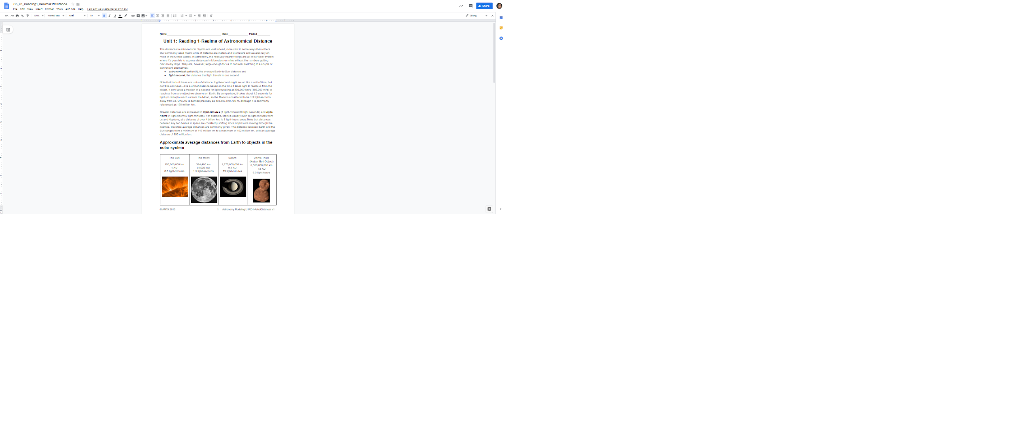

Section 2: Image Analysis

12. Activity 8—Discovering Asteroids

Students have already been introduced to SalsaJ or JS9 in Section 1. In this activity, they will further their image analysis skills by using telescopic images to discover an asteroid.

Apparatus
- Computers with SalsaJ software or JS9
- FITS Images of asteroids in folder U1 Images/Asteroid 1998wt: 1998wt-0245y.fit, 1998wt-0250y.fit, 1998wt-0255y.fit
- Asteroid FAQ (10b Optional Reading-Asteroid FAQ)
- Asteroid animations and images from Unistellar eVscope telescope in “Unistellar Images (Asteroids & Planetary Defense)” folder

Pre-activity discussion
Elicit students’ current knowledge about asteroids with questions such as these:
- What do you know about asteroids?
- Where are asteroids found?
- Do they move? Do you think you could tell by examining an image?
- Do you have any idea whether asteroids, comets and “shooting stars” are the same thing?
- Where do you think the craters on the Moon come from? Does Earth have craters like these? If so, why not as many?
- Should the public be concerned about astronomy in general, and specifically asteroids or near-earth objects (NEOs)? Are asteroids dangerous to Earth?

Show one or more of the following videos listed below to motivate a discussion of the need to monitor near-earth objects.
- Thousands of small dust size particles rain down on Earth daily. Is it important to spot these NEOs in advance and how can it be done?
  - https://cneos.jpl.nasa.gov/about/basics.html. Introduction page for the Center for Near-Earth Object Studies (CNEOS), NASA's center for computing asteroid and comet orbits and their odds of Earth impact.. “Near-Earth Objects (NEOs) are comets and asteroids that have been nudged by the gravitational attraction of nearby planets into orbits that allow them to enter the Earth’s neighborhood.” A multimedia presentation in Flash or HTML is available at this link.
  - Flash multimedia link: https://www.jpl.nasa.gov/multimedia/neo/spaceRocks.html. The teacher will have to select tabs to move through the presentation and not all tabs are narrated. The music is annoying and there is a selection to mute it.
  - HTML multimedia link: https://www.jpl.nasa.gov/multimedia/neo/neo_flash.cfm. This might most effectively used as a webquest performed by students at the beginning of the activity.
- Every 10,000 years or so, on average, a NEO larger than 100 meters reaches the Earth and a local disaster occurs:
  - https://science.nasa.gov/science-news/science-at-nasa/2008/30jun_tunguska/. Audiofile from Science at NASA about the Tunguska event, the largest asteroid impact yet to be witnessed. “In 1908, a powerful asteroid struck the Podkamennaya Tunguska River in a remote Siberian forest in Russia. The asteroid's collision was so powerful that people more than 40 miles away were thrown from their porches and chairs by the sheer force of the impact. It has been more than 100 years since the massive impact leveled about 1,000 square miles of forest. That's like wiping out almost all of the state of Rhode Island.”
  - https://www.space.com/33623-chelyabinsk-meteor-wake-up-call-for-earth.html Video from Science at NASA about the asteroid event over the city of Chelyabinsk, Russia on Feb. 15, 2013. The shock wave produced injured about 1,200 people. Some scientists think the meteor may have outshone the sun. The blast was stronger than a nuclear explosion.
  - http://www.cnn.com/2015/06/27/world/asteroid-day-declaration-irpt/. CNN story from June 30, 2015, about the first Asteroid Day on the 100 year anniversary of the Tunguska Event. The article discusses the movie 51 Degrees North, the inspiration for Asteroid Day (https://asteroidday.org/) and several related stories, including the 100x Declaration, NASAs Asteroid Redirect Mission (https://www.nasa.gov/mission_pages/asteroids/initiative/index.html), which was ended by the White House in December 2017, and NASAs Asteroid Grand Challenge (https://www.nasa.gov/content/asteroid-grand-challenge).
- On an even longer time scale, several hundred thousand years or so, asteroids larger than a kilometer have caused more catastrophic results, such as mass extinction events. Impact debris spreads through the Earth’s atmosphere affecting plant life with acid rain, blocking of sunlight, and firestorms from heated debris.
  - https://www.youtube.com/watch?v=5qJPTjMnwNk Youtube video that provides a brief (2 minute) visualization of the immediate and long-term environmental effects of the K-T (Cretaceous-Tertiary Mass Extinction) event, the asteroid impact that is hypothesized to have marked the end of the Cretaceous period, circa 65 mya. Information about that event is available from NASA: https://www2.jpl.nasa.gov/sl9/back3.html.
With one or more of these introductory materials in mind, how do we track these NEO’s? Tell students they are going to embark on a study of techniques used by astronomers to search for NEOs and other astronomical phenomena.
Lastly, show students the animations and images in the “Unistellar Images (Asteroids & Planetary Defense)” folder. We recommend you show them in the order designated below and explain that these are recently discovered and observed near-Earth asteroids with small backyard citizen astronomer telescopes.

- UnistellarAsteroid_2019XS_AsteroidTrajectory.gif
- UnistellarAsteroid_2019XS_ApproachAsteroidPerspective.gif
  - Note this is an animation showing what it would look like if a camera were attached to the asteroid 2019XS as it approached and left Earth’s near orbit
- UnistellarAsteroid_2019XS_Observation.gif
  - Observation taken with a Unistellar eVscope, a small backyard digital smart telescope
- UnistellarAsteroid_Heracles_20211104_Observation.gif
  - Observation taken with a Unistellar eVscope

The optional reading (U1-Act6_Optional Reading-AsteroidFAQ.pdf) is included as a teacher resource but may also be assigned as a reading for students either before or after the activity.

Performance notes
Have students open the the three images of asteroid 1998wt with SalsaJ (or JS9) proceeds exactly as done in Activity 3. A word about the images in the asteroid folder: The folder contains six images taken from two different telescopes/observatories: Yerkes Observatory (y) in southern Wisconsin and Gettysburg College Observatory (g) in Pennsylvania. The images were taken simultaneously from the two observatories at 5 minute intervals. They are labeled according to the observatory and time taken. For example: 1998wt-0245y.fits was taken at Yerkes Observatory (y) at 2:45 UT (Universal Time—the time at Greenwich England, commonly used as a standard for astronomical observations). For this activity the students will open the three images containing the y.

Once opened, line them up side by side, as shown below, and adjust them for clarity using the Brightness & Contrast tool. If this tool has not already been introduced then use the following process: Click on the icon 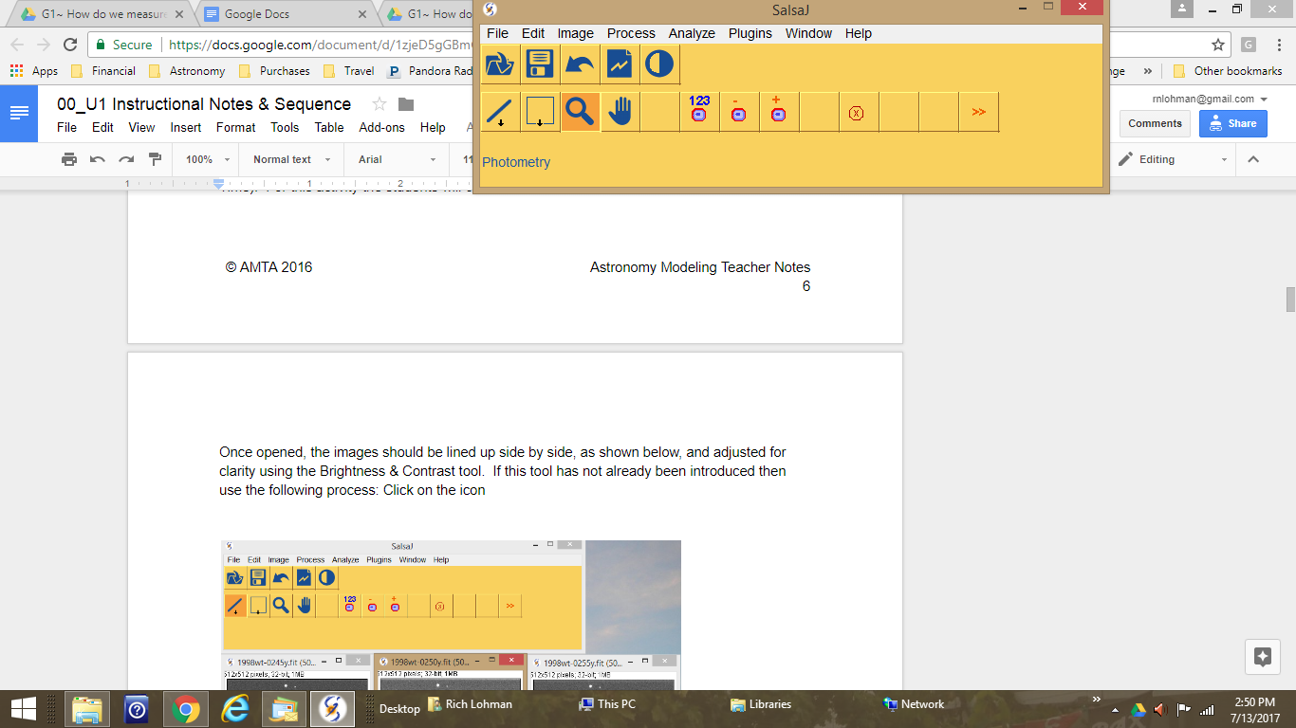, Brightness and Contrast. Click once on the Auto button on that window. If needed for more clarity, click a second time. You can also move the sliders on that window for more manual flexibility.

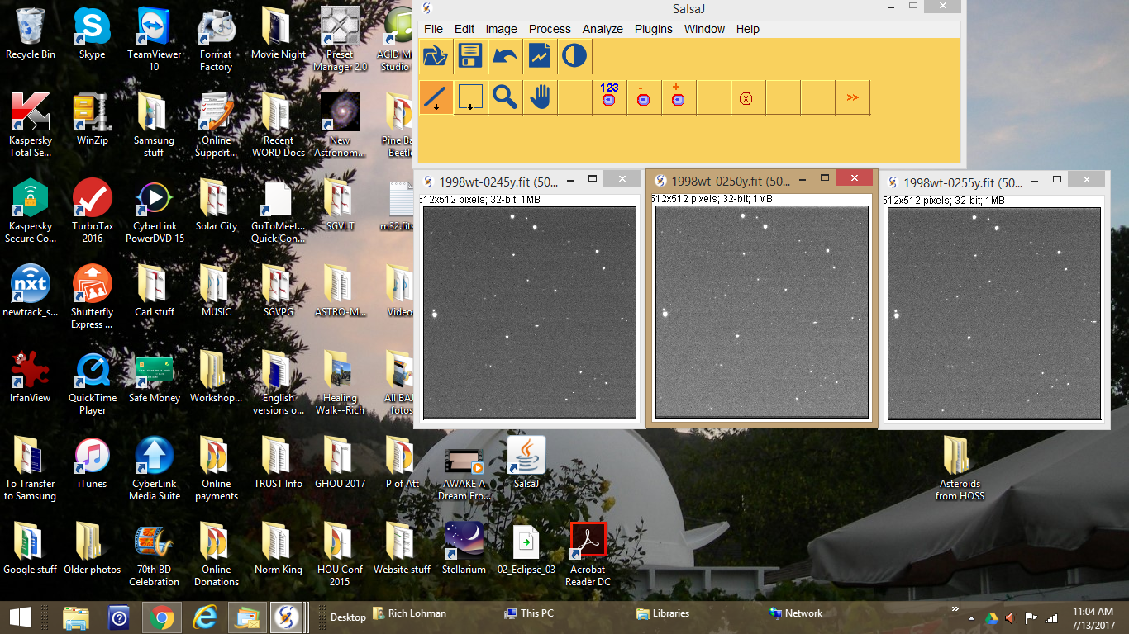
At this point tell the students that there is an asteroid in each of the three images that has shifted its position over the time intervals shown. They can be encouraged to visually locate the asteroid just using their eyes. Very often, students will find it in each image. Have the students who see the asteroid move their cursor to the location so they can obtain and record the (x,y) coordinates of that position. As the cursor moves in each photo, the (x,y) coordinates are shown in the yellow band of the SalsaJ window just below the icons. Note that the image above does not show a cursor location.

Often astronomers, who are looking for asteroids in images such as these, cannot find the object visually. They require additional tools. Two such image processing tools will be used in this activity: image stacking (from which an animation can be made) and image subtraction (to remove all stationary objects).

- Image Stacking: Images are overlaid, allowing the movement of an object to be viewed as an animation . With the three images open click on the Image menu, then Stacks, then Images to Stack. Once the stack has been formed then one can click on the slider at the bottom of the stack to toggle between the images; however, only one image will be visible at a time. Toggling among images will show the asteroid in motion. The stack can also be automatically set in motion by going through Image>Stacks>Start Animation. The motion can be slowed down by going through the same menu sequence to Animation Options and changing the speed.

- Image Subtraction: The brightness value for one image is subtracted from another, rendering the second image black, while the first image remains white. If the images are still in a stack, unstack them by going through Image>Stacks>Stack to Images. To subtract one image from another, click the Process menu, then Image Calculator. Select the following in the pull-down menus for the three boxes: Image 1: 1998wt-0245y.fit, Operation: Subtract, Image 2:1998wt-0250y.fit; check Create New Window, and select OK.

After subtraction, one asteroid position will appear white and the other black since one asteroid position will have positive brightness Counts and the other asteroid position (the one subtracted) will have negative brightness Counts. No stars should be visible in the processed image since their positions did not change between the two images and the brightness values would cancel. In practice, you will observe that, since the images are not perfectly aligned, the positions of stars will appear as black and white spots that are very slightly offset from one another.

Repeat the process for the other possible image pairs:
- Image 1: 1998wt-0250y.fit, Operation: Subtract, Image 2:1998wt-0255y.fit; check Create New Window, and select OK and
- Image 1: 1998wt-0245y.fit, Operation: Subtract, Image 2:1998wt-0255y.fit; check Create New Window, and select OK.

Approximate answers, the pixel coordinates, for the positions of asteroid 1998wt taken from Yerkes Observatory: (272, 288) at 2:45, (382, 281) at 2:50 and (496, 275) at 2:55.

If there is time remaining, and/or some students have finished ahead of others, they can be encouraged to perform the same search techniques to find the asteroid in the images from the Gettysburg observatory (filename is encoded with a g). These images will be used at the end of Unit 1, but that will be for a different purpose.

Approximate answers, the pixel coordinates, for the positions of asteroid 1998wt taken from Gettysburg Observatory: (296, 483) at 2:45, (360, 483) at 2:50 and (425, 475) at 2:55..

Post-activity discussion
Rather than a whiteboard meeting, simply review their findings as a whole class. Students’ coordinates may differ slightly depending on where they placed their cursor on the images. This is an opportunity to discuss error and uncertainty in measurement. Ask them if the speed of the
the asteroid and distance to the asteroid can be determined from these pictures. They should conclude that while they know the time that elapsed they do not know anything about the distance traveled. The focus of the remainder of this unit will be in developing the tools necessary to measure how far away this asteroid is and how far it travels in 10 minutes. This information allows scientists to determine if an asteroid is a threat to Earth.

Extensions
You can have your students actively searching for asteroids by participating in the International Astronomical Search Collaboration (http://iasc.hsutx.edu/), an educational outreach program for high schools and colleges, provided at no cost to the participating schools. IASC (pronounced Isaac) is based at Hardin-Simmons University (Abilene TX) and is a collaboration of many observatories and institutions worldwide.

Source
(This activity derived from HOU-WISE Asteroid and Solar System Science (Hands-On Solar System), http://handsonuniverse.org/usa/participate/wise/ and http://static.lawrencehallofscience.org/hou/hs/wise/asteroidWISE.pdf
http://static.lawrencehallofscience.org/hou/ms/HOSS-SG2006.pdf and
http://static.lawrencehallofscience.org/hou/ms/HOSS-TG2006.pdf

13. Activity 9—Measure Lengths in Images

In this activity students learn to use images (in this case images of pennies) as reference objects to find the lengths of objects such as paper clips, pennies, note cards, etc. using proportions. Students will use percent error to determine the characteristics of objects that give the most reliable measurements of length.

Apparatus
- Pennies
- 30-cm rulers
- Full Moon image U1Act7_moon2-Full.fts in folder “Images for U1”
- Images of pennies beside fairly flat objects;

Pre-activity discussion
Project your screen and open SalsaJ and open the image of the Moon. Have students do the same.

Demonstrate for students how to center the image of the Moon using the Scrolling tool (hand) and to magnify the image using the Magnifying glass tool and then have them try out the magnifying tool with their own moon image.

With high enough magnification, the Moon becomes a collection of squares of differing shades of grey. Once they discover this, ask them what these little squares are. Someone will probably come up with the name pixels. (If not you can supply the name)

Have students speculate about how these pixels might be used to measure something on an image; e.g., these squares form a grid and the diameter can be found by counting the squares in the grid. Show students where the origin of the image is (in the upper left corner) and call their attention to the x-y counters and the value counter on the SalsaJ menu bar. Ask them what they think these numbers represent and what units are associated with the values.

By scrolling through different squares, they should be able to deduce that x and y are the cursor’s coordinates, the unit is pixels, and the given value is a measure of brightness. NOTE: Bright pixels have higher values, however, even a dark pixel has a value greater than zero.
Show students how to use the Straight line selection and Plot Profile tools to measure distances on the image in pixels. Then challenge them to find the diameter of the Moon in the image in pixels [e.g., 576 Answer]. Now that they have the diameter of the Moon in pixels, can they determine what they need to know to determine how big a pixel is in this image? (Hopefully they will deduce that they need to know the diameter of the Moon in a unit other than pixels). They can look this up in web search [3,474 km]. Have them develop the conversion method (e.g., pixels/km or km/pixel) [e.g., 3,474 km / 576 pixels = 6.03 km/pixel].

Now that they have a method, project the image of a penny beside an object that is not a standard size such as a used pencil (pennypic04 in Resources folder). Have them use the method they developed to determine the length of the object (pencil) in the image. Calculate a class average in the spreadsheet that you can compare to the accepted diameter of a penny [1.095 cm]. Take this opportunity to discuss error and uncertainty in measurements.

This is a useful time to introduce the formula for percent error: $\left|\frac{measured value - accepted value}{accepted value}\right|x 100$

Introduce students to the 5% rule of thumb: For a measurement to be considered reliable, the percent error should be 5% or less. A discussion of sources of error in measurement of the pennies would be appropriate here as well.

Performance notes
The images you use for this activity must be installed on the student computers or a shared drive accessible by students
from SalsaJ.

Have students work in groups (ideally in pairs) to determine the length of the object in several of the available images. It is also useful to have more than one group measure the same image to allow comparisons. The picture of the coins (pennypic02) contains three unknown objects -- quarter, nickel, and dime; assign a different coin to each group rather than having one group apply the same conversion factor to all three coins.

For each image, students measure the number of pixels in the penny, calculate the conversion factor (cm/pixel), and calculate the length of the object using that conversion factor. Note that the cm/pixel are not the same for each image. Have students enter their data in a spreadsheet in a shared drive or on a whiteboard.

Post-activity discussion
Have students compare their individual values to average values for the same object. Choose some object for which there is a large variability in the average length among groups and discuss sources of error that contribute to variation among groups for the same measurement. Speculate on ways to quantify the size of their individual errors. Discuss what information would be necessary to use percent error -- accepted values of sizes of unknown objects.

Come up with a list of acceptable practices for measuring with pixels to minimize measurement error.

14. Activity 10—Practicum-Measuring using Images of Reference Objects

Students will apply the skills learned in the previous activities to find the height of the classroom ceiling in meters using only a notecard, camera and SalsaJ software. This activity is designed to be a formative assessment.

Apparatus
- Computers with SalsaJ (or JS9) software
- Smartphone with camera (at least one per group)
- 3” x 5” notecards (at least one per group)

Pre-activity discussion
Ask students how they could find the height of the classroom in meters using just a 3” by 5” notecard and a camera. List any suggestions of possible methods on the board.

Lead students to the idea of taking a picture of the notecard with the full wall visible from floor to ceiling. The known width of the notecard will allow them to determine the conversion factor from pixels to meters. Remind students of the necessary conversion for the notecard: 2.54 cm=1 inch.

Performance notes
Students will find that a dark section of wall behind the note card will work best, but in true Modeling fashion, let the students figure this out.

As with the penny images in the previous activity, the notecard needs to be in the same plane as the wall (i.e., taped to the wall rather than held a distance from wall) and the camera needs to be directly above the notecard when the image is taken.

The teacher will need to determine the accepted value of the height of the wall prior to the activity or include time for students to develop a class average to use as the accepted value.

Post-activity discussion
Students should whiteboard their procedures, measurements, and calculations. Provide a table visible to the entire class on a whiteboard to fill in their value for the height of the room.

When all the groups have submitted their value, ask how we could compare the accuracy of the values. Students should realize that the accepted value of the height of the room is needed. Either provide the accepted value (determined previously by the instructor) or have students measure with meter stick or measuring tape) and have each group calculate their percent error.

Identify the practices that the groups with smaller percent errors used compared to other groups.

Section 3 — Using ratios and geometric methods for determining distance

15. Activity 11—Distance-Size-Angle Geometric

Relationships

This activity is designed to acquaint students with the relationships between angular size, physical size, and distance to an object.

Apparatus
- Several paper disks (or circles drawn on paper) of various diameters (7 cm to 20 cm in diameter) posted around the room. A file with circles of 7, 9. 11, 13, 15, 17, and 20 cm diameters are included in Resources (U1Act9_circles.pdf). If you want students to have more practice making linear measurements, open the file as a Word document (U1Act9_circles.doc) and delete the diameter measurements from each circle before printing. Note that the file is a Word document; it will not format correctly as a Google doc.
- Optional: Assortment of balls and circular objects from small to large (basketball, tennis, styrofoam, circular magnets, paper disk cutouts, pictures)
For each group of three students:
- String (light cotton, ~3 meters)
- Balloons (which can be inflated up to 6-10 inches)
- Protractors (one/group)
- Meter Stick (one/group)
- Adhesive tape

Pre-activity discussion
Explain that we're limited in the types of measurements we can make of celestial objects with our telescopes from our Earthly home. Some properties that can be measured are brightness, color, and change in position. In a previous activity (Activity 6: Discover Asteroids) students used the change in position of an object in a sequence of images to discover asteroids.

Finding sizes, distances and actually measuring the change in position are more challenging than simply identifying change in position. We cannot stretch a tape measure across the Moon to measure its diameter nor can we extend a tape measure to the Moon to measure the distance from Earth. But there is a measurement that we can make from Earth that is central to astronomy: angular size. Ask students, “What is angular size?” It’s not necessary to arrive at a precisely correct answer at this point because the activity will clarify the meaning of angular size.

To determine how to measure the distance and physical size of an object in space, they’ll set up some simulations in the classroom.

Part 1: Similar triangles

Preliminary questions
Ask students to hold a small circle (or disk or ball) so that it barely blocks out the circle (or disk) on the wall? Point to one of the disks or circles posted on the wall of the classroom and ask how they could measure the size of the distant object? How would the measurement change depending upon how far away you are from the circle? What data do you need to collect?

Students may suggest collecting data such as how far they are from the circle on the wall, distance from blocking circle to the wall, distance from blocking circle to the eye, diameters of circles, and angles. Does it matter which person is holding the smaller circle? If so, what would be a more efficient approach -- having the same person always hold the blocking circle or collecting measurements from two different people? Have them come up with the most efficient method.

Performance notes
Students can tape the larger circle in each large:small pair to the wall and measure the distance from their eye (for safety, use the side of their head even with the eye) to each of the aligned circles. Their challenge is to collect data that will model the relationship of distance and diameter (not angular size for this part).

It may be useful to establish a uniform convention of symbols for the measured variables, e.g.:
dB = diameter of blocking circle DB = Distance to blocking circle
dL = diameter of larger circle DL = Distance to larger circle
Teachers may opt to use other symbols, however, these are designed to allow students to use pre-agreed-upon symbols (d=diameter; D=distance) when the formula for small angle approximation (θ ≈ d/D) is introduced later in the activity.

Ideally, students should collect data for at least five blocking circles: large circle pairs to allow plotting of relationships. If possible, have different groups measure identical blocking circle:large circle pairs to allow comparisons between measurements

Analyzing data and making predictions
After they have collected data, have them discuss in groups what to do with it. Remind them of their challenge: use data to make a representation of the relationship of distance and diameter (not angular size for this part).
Ask them to think about possible mathematical relationships among the measured variables of diameter and distance for the pairs of circles. Remind students that they have diameter and distance measurements for both the blocking circle and for the corresponding larger circle. Guide them to the realization that they must calculate ratios (i.e., use the division operator) of the two measurements for each circle to explore the relationships.
Possible examples of relationships for students to explore are:
dL/dB = DL/DB (direct relationship) dL/dB = DB/DL (inverse relationship)
dB/DL = dL /DB dB/DB = dL/DL

If using LoggerPro, students can add a New Data Set called Ratios, make new calculated columns for each ratio, and graph each pair of ratios. If using Excel or Google Sheets, make sure students know how to enter data effectively to create line plots.
Eventually, they should come to the conclusion that the valid relationship is the direct relationship:
- dB/DB = dL/DL

Which is equivalent to dB/dL = DB/DL (dividing both sides by dL and multiplying by DB).

How do we know if this mathematical representation is useful? In astronomy, the distance (D) is generally too far away to directly measure the diameter (d) of an object in space. If the distance is too far away, what can you measure DIRECTLY? Does our chosen formula (dB/DB = dL/DL) allow us to predict diameter and distance of the large circle from direct measurements of the blocking circle? Have students rearrange their equation to solve for dL and for DL.
- Diameter: dL = (DL x dB) / DB (multiplying both sides by DL)
- Distance: DL = (dL x DB) /dB (dividing both sides by dL and inverting both sides)

In both cases, we can predict one variable (diameter or distance) for an object that we do not have access to because it is too far away. Now, if one can make a prediction in which all but one variable is known, the unknown variable can be computed using the relationship and then checked by measurement to confirm the prediction. In our current simulation, diameter was known and we measured distance. Have each group predict distance using DL = (dL x DB) /dB for one of the large circle:blocking circle pairs that it did not measure and check by measurement. Does our chosen model allow accurate predictions?

Finally, point out that the lines representing size (diameter) and distance form a triangle. Furthermore, if radius is used in place of diameter, the lines form a right triangle. Students who have had trigonometry may see that if they use the radius and the distance to form a right triangle that they can compute the angle by using tangent (tan = opp/adj, often remembered as TOA). Recalling this concept will help set the stage for angular size in the next part of the activity.

Part 2: Angular Size

Preliminary questions
Point to several objects on the wall, e.g., a clock, a picture, a chart, a window. With each object, ask, “How big is that object?” Expect answers in units of length (centimeters, meters). Identify all those answers as the physical size of the object.

Then have each student pick one particular object on the wall and imagine two pieces of string (or one long piece folded) extending from the two sides of the object forming lines back to their eye. Have them imagine the angle that the string forms at their eye when the two sides are of equal length. It may be helpful for them to hold their hands up by their eyes to imagine the string(s) forming this angle. This angle is called the angular size of the object.

Ask: them what variables determine the size of this angle. Hopefully they will identify distance to the object and physical size (width or diameter) of the object, since they investigated that relationship in Part 1 with diameter as a measure of physical size. Challenge them to characterize this new variable, angular size, with the other two variables, distance and physical size (or linear size, e.g., diameter, radius). At this point, it may be useful to begin referring to physical size as linear size in contrast to angular size. What new relationships can be explored by adding angular size?

Performance notes
Have them work in small groups with pieces of string and different sizes of balls, balloons, or the circles/disks to find the relationships among distance, diameter and angle. If using balloons or balls, they should use two spheres of different sizes.

Angles should be measured in units of degrees using a protractor.
- The angles to be measured will be relatively small, which requires accurate and precise use of protractors
Alternatively, students can use the paper circles from Part 1 to investigate the relationship among distance, diameter, and angle. Have each group fold two of the circles (smallest and largest they were tasked with measuring in Part 1), lay the folded halves on a flat surface such as a desk, table top, or floor, and lay the string on the flat surface to find the necessary distance. This allows students to practice using the protractor on a flat surface where their measurements will be more accurate. Students can also tape the folded circles along the length of the meter stick at the distances they measured in Part 1 or collect new measurements. If using this procedure, students will create a physical model with circles taped to a meter stick like the picture below when viewed from above the flat surface.
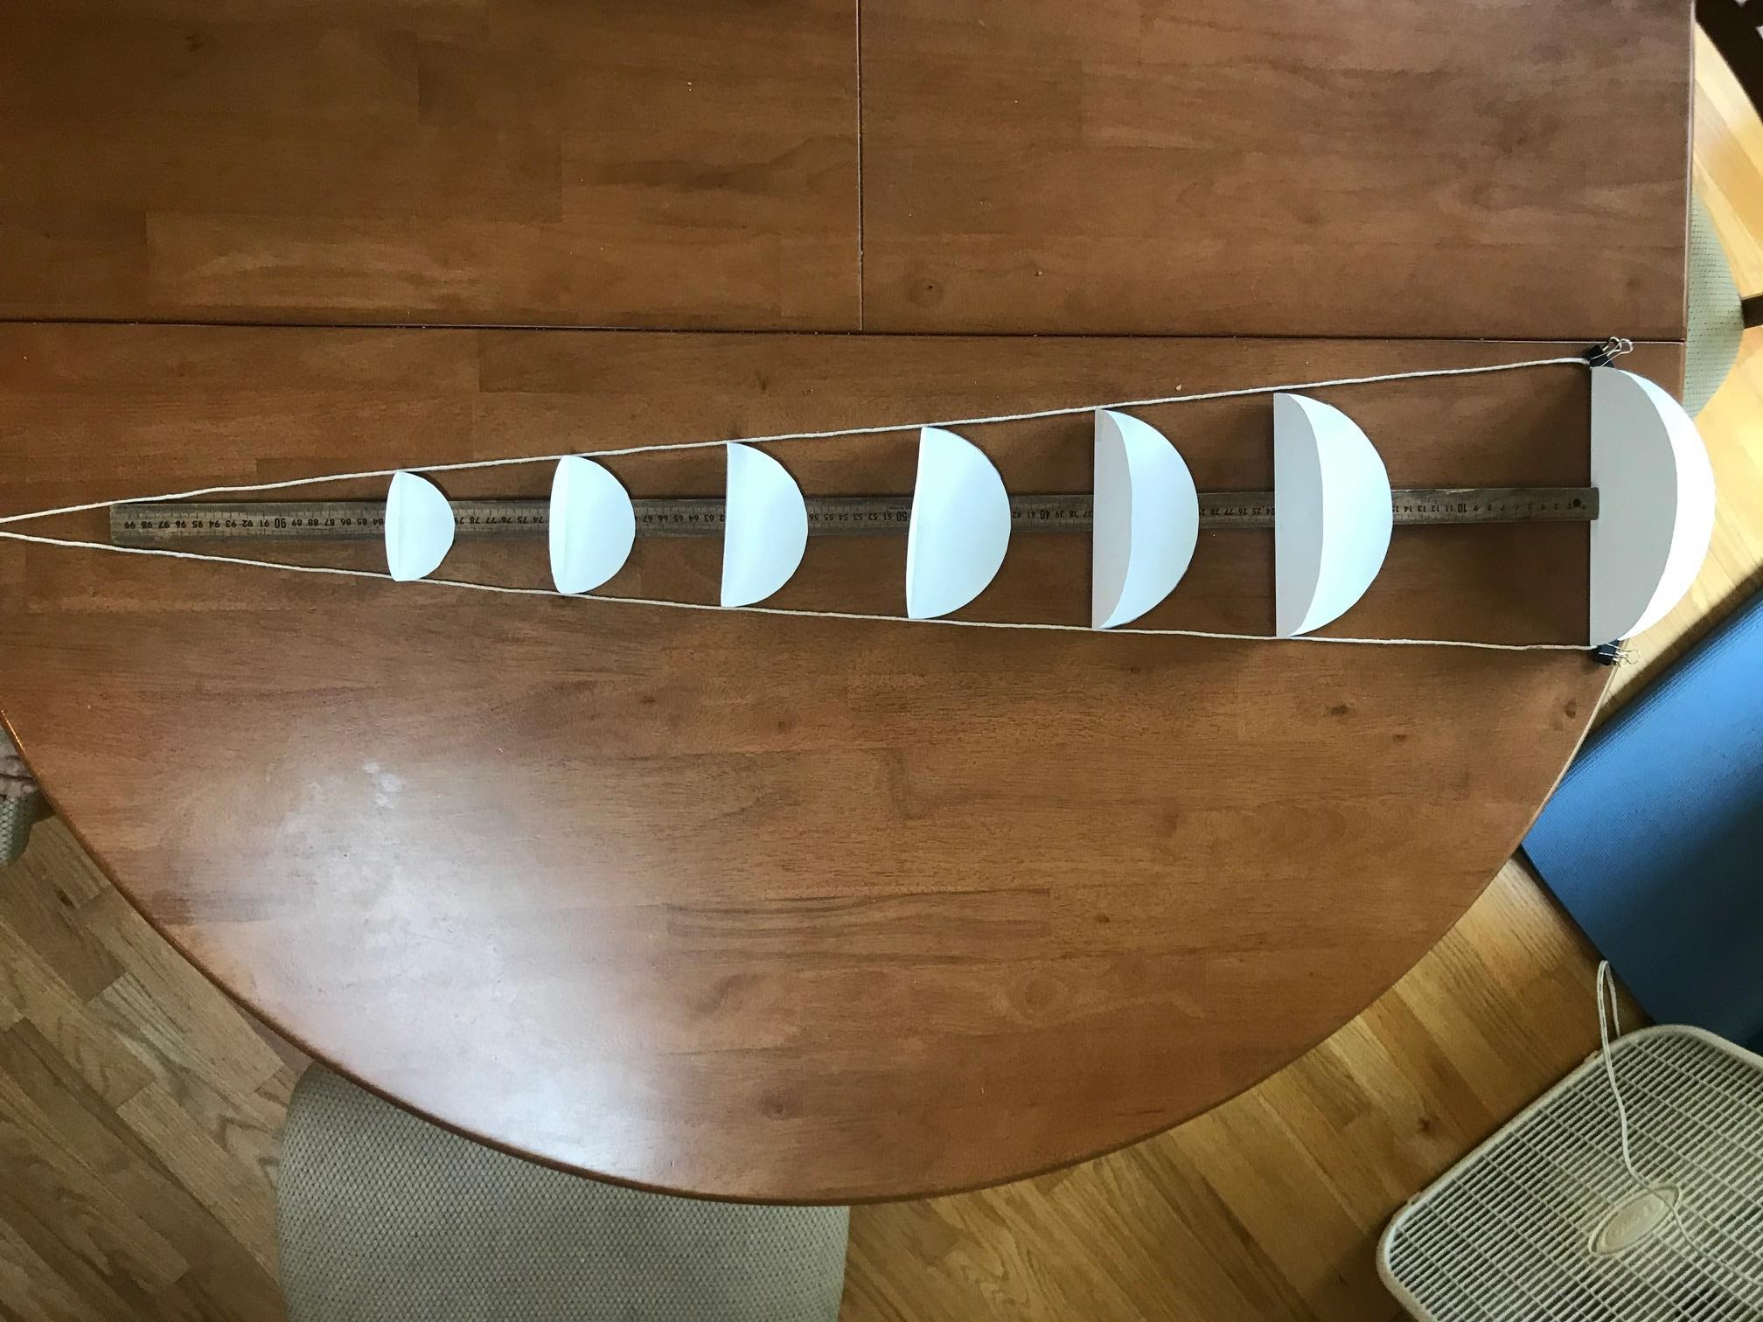

Analyzing data and making predictions
Have each group whiteboard their findings. Questions to consider are:
- What changes as the string gets longer and your eye is farther away from the object?
- What stays the same?
- How would you summarize the relationship between angle, distance and diameter?

Post-activity discussion
During the board meeting help students realize that for any object, angular size changes as the object gets closer or further away from the observer: The closer the object is the larger the angular size, the further away the object is the smaller the angular size. And, in general, the angular size of an object depends on both distance and diameter (physical size).

Measuring angular size is a critical measurement we make in astronomy. Remind the students that angular size is one of the few things we can directly measure from Earth.

Distinguish the difference between and angular size of an object and angular distance between objects. Both are angle measurements, but angular size usually refers to the angle subtended by a single object and angular distance is a more general term that can involve two or more objects. Have students recall how they identified an asteroid in Activity 6. The two positions of the asteroid were identified by pixel coordinates, but we did not take the extra step of finding the distance the asteroid traveled, either angular distance or linear distance.

Part 3: Approximating Angular Size (Deployment of angular size)

Next, students will use fist, thumb, and pinky to make approximate angle measurements. They will need to work in teams of at least 2: one student holding the string around their fist with the other hand holding the string ends near their eyes, one student measuring the angle with a protractor. In the pre-lab discussion have them think about how best to determine the angular size of their fist, thumb and pinky. Guide them toward the idea that they should make their measurements in the same way they will use their fists, etc. in the field, holding them at arm’s length from their eye. When they come to a consensus on this let them do this in small groups and whiteboard their results. Each member of the group should make measurements for their own fist, thumb and pinky, so there is a range of data to compare with the rest of their class.

At the board meeting that follows, compare and discuss average value for fist, thumb and pinky
A fist is typically around 10°. A thumb around 2° and a pinky around 1°. These can be used as handy “angular measurement tools”.

With these coarse angle-measuring tools, have the students look at more distant objects outside the classroom. Have them estimate the angular sizes (or angular heights) of a distant building, a tower, a window in a house, etc. Direct them to measure not just large objects but also objects with an angular size less than one degree. Let them compare results and discuss the precision of their angular measurements. Prompt them to consider when a measurement is “good enough?”

Post-activity discussion
At this point students have identified the relationship between distance, diameter and angle.
If they know a little trigonometry, they know that if they use the diameter and the distance to form a right triangle, the angle can be found using the tangent function: tan θ = d/D; where d is the diameter of the object and D is the distance to it.

d

D
θ

For very small angles, tan θ ≈ θ, so θ ≈ d/D, when θ is expressed in radians (1 radian = 57.3°).

This formula is the Small Angle Equation (also known as the small angle approximation or the small angle formula).
$θ (radians) ≈ \frac{d}{D}$ or $θ (degrees) ≈ \frac{d}{D} x 57.3 degrees/radian$

Optional: have students use either of these formulas to determine the angular sizes of objects at various distances. (Note that the distances must be either provided by the teacher or measured by the student.) They should express their answers in what they believe to be the most appropriate unit (e.g., degrees, arcminutes, or arcseconds).

Extensions
- Additional practice: https://spacemath.gsfc.nasa.gov/algebra2/CH13v3.pdf
  - General Angles and Radian Measure 13.2.3
  - General Angles and Radian Measure 13.2.4
- Khan Academy video on radian measure
  - https://www.khanacademy.org/math/algebra2/trig-functions/intro-to-radians-alg2/v/introduction-to-radians

16. Worksheet 4 - Angular Units

This worksheet may be used to provide students with practice converting between degrees, arcminutes and arcseconds if needed.
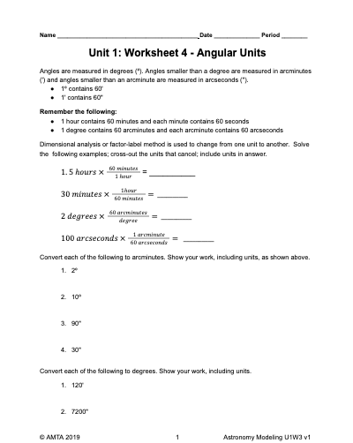

17. Optional Worksheet - Small Angle Approximations

Provides students with practice using the small angle equation to calculate angular sizes of the Moon, the Sun, the planet Jupiter and the galaxy Andromeda.

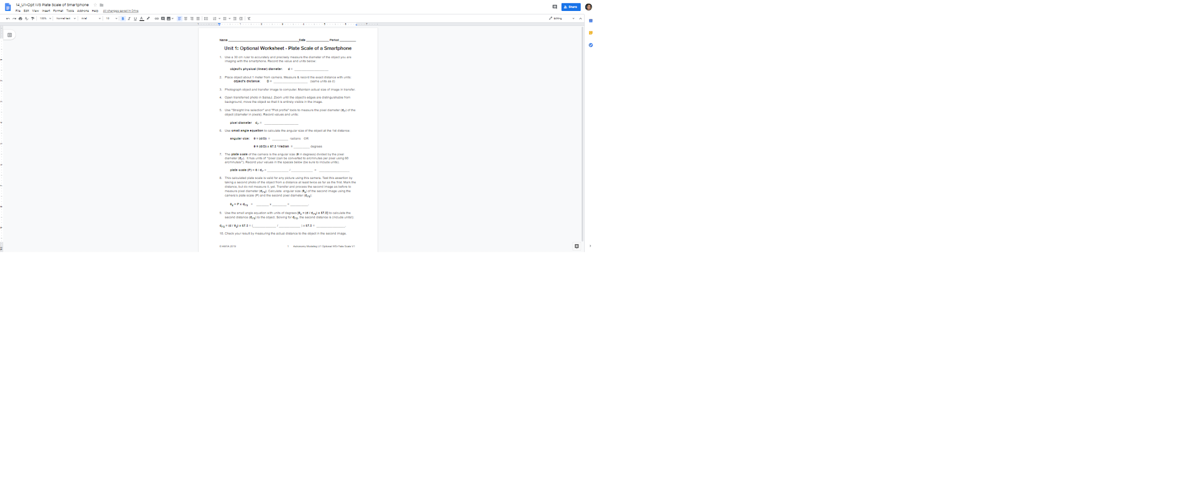

18. Optional Activity - The Smartphone as a Mini-telescope and Optional Worksheet-Plate Scale of a Smartphone

In upcoming activities, we’ll be learning some pretty clever ways that we can determine distances to astronomical objects. Once we know the distance to an object, if we can measure its angular size then we can find its physical size from the Small Angle Equation:
- θ (radians) ≈ d/D OR
- θ (degrees) ≈ (d/D) x 57.3 degrees/radian

In this optional activity, students calibrate a smartphone camera to act as a mini-telescope by taking a picture of an object whose diameter and distance away are known. That calibration results in a factor known as the plate scale of the camera, that can then be used to determine angular distances in any image the camera takes.

Students who do not do this activity will be introduced to plate scale and determine plate scale of a camera from images using the Small Angle Equation in Worksheet 4-The Geometry of Parallax later in the unit. For students who do the optional activity, Worksheet 4 can be used as a practicum for the concepts learned here.

Apparatus
For each group:
- A smartphone camera (more than one if desired)
- One object (20 cm to 30 cm in diameter) for each group to take an image
- meter stick (one per group)
- Computer(s) with SalsaJ (Activity is written for use with SalsaJ) and basketball image (U1 OptAct Plate Scale_Basketball.jpg) installed
- For each student: Optional Worksheet - Plate Scale of a Smartphone.

Pre-activity discussion
Show the “Basketball” image on their computers with SalsaJ . If the image opens sideways, use Process>Rotate to turn it 90° to the right. Ask what we need to know about the image to calculate the angular size of the basketball using the small angle formula.After they have correctly identified the diameter of the basketball and its distance from the camera lens, tell them the basketball is 24 cm in diameter and it is located a distance of 2 m from the camera lens.

Have students use that diameter and distance to calculate the angular size (in degrees) of the basketball from the small angle formula: θ (degrees) ≈ (d/D) x 57.3 degrees/radian. [Ans: ~ 6.9 degrees]

Discuss what they can measure in the image to relate the physical size (diameter) of the basketball to the angular size. Guide them if necessary to the notion that they can find the basketball’s diameter in pixels.

Measure the pixel diameter of the basketball using the Straight Line Selection tool and Plot Profile in SalsaJ.[about 330 pixels] There are also several alternative methods to this one which you may already be using.

The pixel diameter represents the angle subtended by the basketball in the image as viewed from the position of the camera which took the image. Recall the string angles from Part 2 of Activity 9 (Distance-Size-Angle Geometric Relationships). It may be helpful to draw a picture showing the camera lens and rays of subtended angle created by the diameter of the basketball.

Students will need to develop a conversion factor with units of degrees / pixel that is specific to the camera that took the basketball image, [ratio of angular size / pixel diameter] and then, calculate the ratio of angular size / pixel diameter for the camera [~0.021°/pixel]. This ratio is called the plate scale of the camera, and has units of radians/pixel.

Once determined, the camera’s plate scale can be used for measuring angular sizes and angular distances in any image taken by that camera!

Finally, convert their calculated plate scale to arcseconds/pixel, since that is the most commonly used unit for most astronomical applications. [~75 “/pixel]

Performance notes
Before attempting this optional activity you will want to experiment with the computer/internet system that is in place to ensure that students with smartphones will be able to transfer images from their phones to their computers for use with SalsaJ or be accessible to the web-based JS9 image processor.
- In some ways the JS9 software is easier, since it can accept an image directly from a smartphone or tablet.
- The simplest procedures to transfer files to a computer for use in SalsaJ would be a direct transfer via a charging cable or a wireless transfer via an email or text. Another option would be some kind of transfer of the images to a class server, for later access by all the students, including those without smartphones.
- The critical aspect in this transfer is that the two images are exactly the same file size (i.e. MB and pixel dimensions). For example, when transferring the image with an iPhone, students select to scale the image to Actual Size.

See the videos in the “SalsaJ How to Videos” if you or students need a review on the SalsaJ tools used in this Activity. There are also several alternative methods which you may already be using.

Distribute the optional worksheet (14_U1-Opt WS Plate Scale of Smartphone). Students can work individually, in pairs, or in small groups to complete the worksheet using their notes from the Pre-activity discussion. Have students record the plate scale associated with their smartphone camera for use later in the course.

Extension: Plate Scale Practicum-Measuring Space Using Geometric Ratios
Have students determine the height of a distant object using their calibrated smartphone camera and SalsaJ or JS9 software. Locate one or more sites around the school campus where the activity can take place. A reasonably tall, distant object (at least 30 meters away) such as a building, flagpole or tree must be viewable from a spot where students can stand to take pictures. Having some other recognizable objects in the scene would be good as clues or references for size.

19. Activity 12 – Introduction to Parallax

This activity introduces parallax as it is used by astronomers to measure the distances to relatively nearby astronomical objects. In simplest terms, astronomers measure a star's apparent movement against the background of more distant stars as Earth revolves around the sun. Parallax is considered a standard of measurement in astronomy because it relies on geometry rather than physics.

Pre-activity discussion
Ask students to do the following:
With one eye closed, hold your thumb at arm's length in front of your eyes. Notice where you see your thumb against the distant background of the wall, a window, a picture, etc.

Keeping your thumb in the same location, switch eyes, i.e. close the open eye and open the closed eye. Notice where you now see your thumb against the background.

Repeat the process of switching eyes back and forth several times.

Ask them what they observe as they switch eyes?

Now have them move their thumbs a few inches from their eyes. Repeat the above process of switching eyes.

How is what they are seeing different from the first case?

Break the students into small groups and have them whiteboard to explain what they observed.

Post-activity discussion
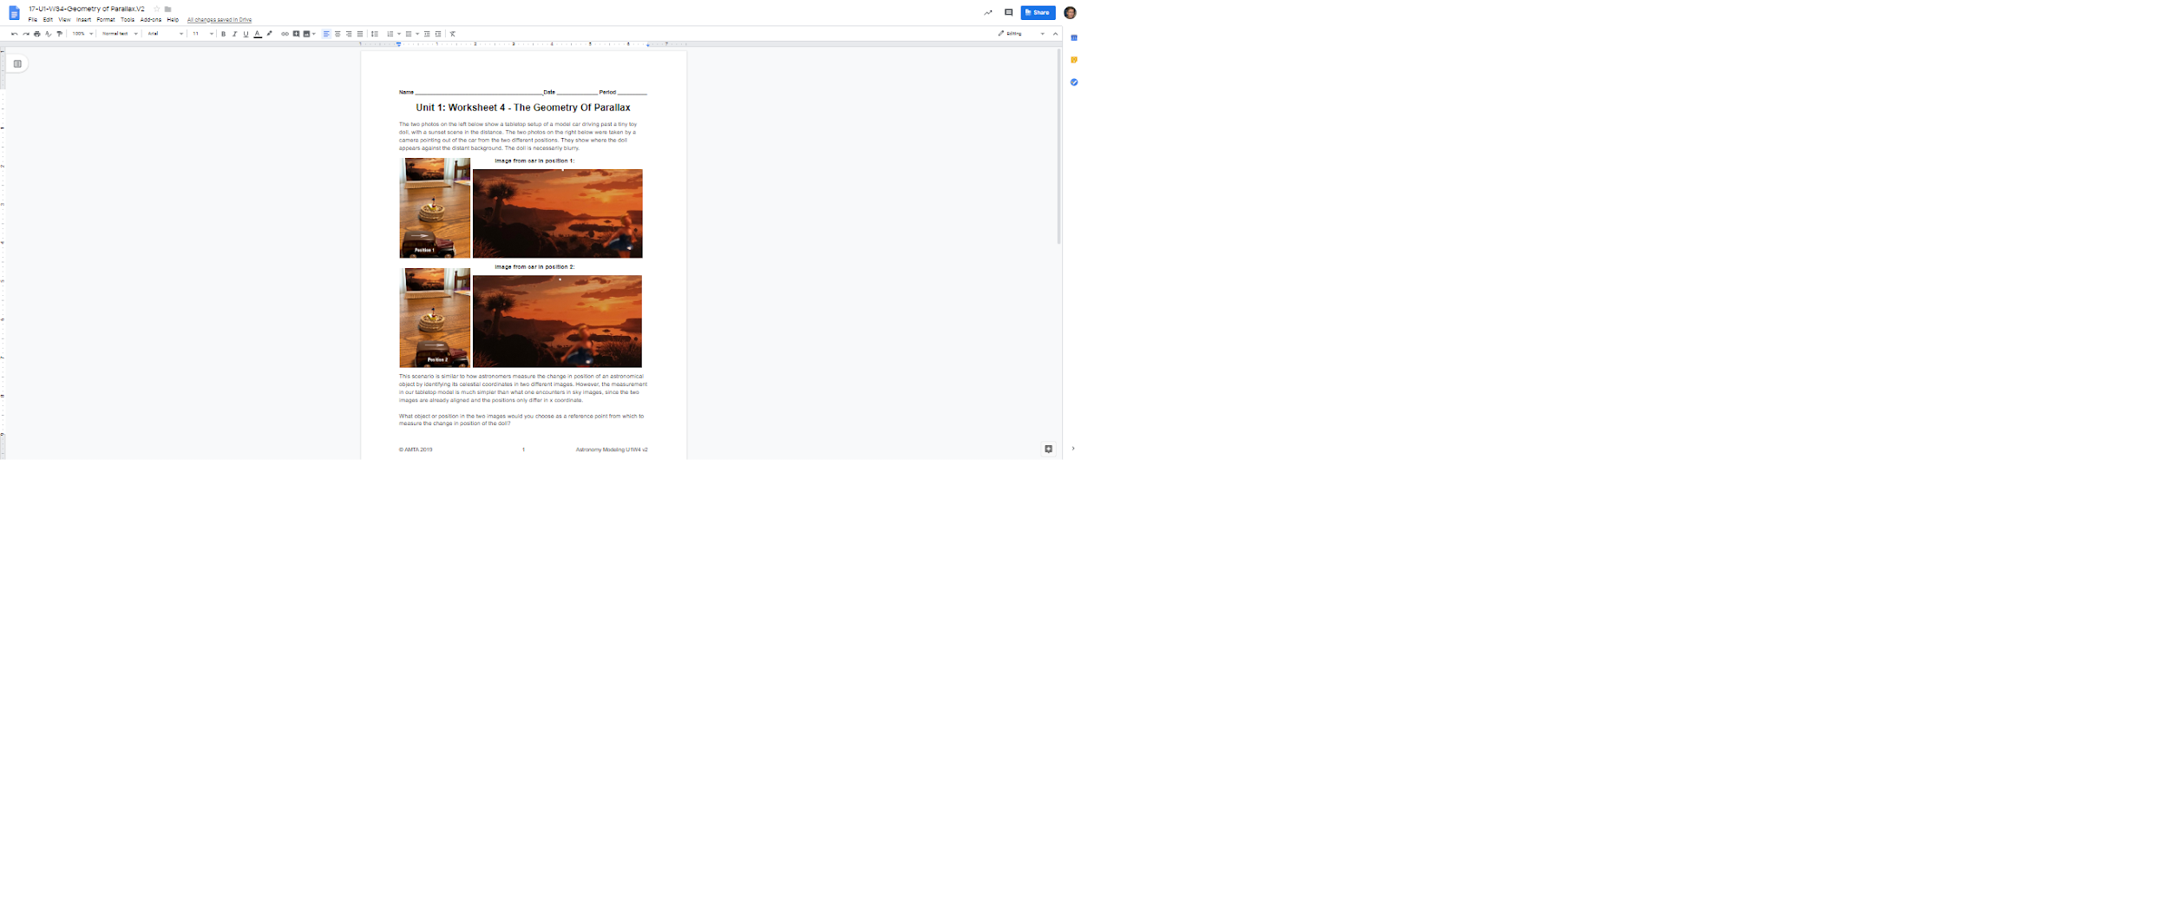
Bring the students back together for a board meeting to share their results. Look for a general understanding of the apparent shift of the thumb against the background, and elicit the difference between the shift when the reference object is closer to the eye vs. further away from the eye. Identify the phenomenon of this apparent shift of the thumb against the background wall as parallax or parallax shift.

Ask them to consider how this might apply to distant objects such as planets and stars.

Extensions
Video explaining parallax from Las Cumbres Observatory: https://www.youtube.com/watch?v=iwlMmJs1f5o

20. Worksheet 5 -The Geometry of Parallax

This worksheet explores the geometry of parallax and outlines how it is used to find distances, including calculation of plate scale of a camera.

For students who completed the Optional Activity-Smartphone as a Mini-Telescope and Optional Worksheet-Plate Scale of a Smartphone, this Worksheet can be used as a practicum for the concepts learned in the optional activity.

Pre-worksheet discussion
A good introductory video for students to see before using the worksheet is the first part of the video at the Las Cumbres Observatory website:
https://www.youtube.com/watch?v=iwlMmJs1f5o

That video starts out with a commonly seen scenario where one is riding in a car and observing that objects nearby seem to move against the background of distant objects. That model is the basis of photos seen in the worksheet, which is a table-top representation of how things appear from a moving car.

Performance notes
The images (U1WS4_dollparallaxImage1 and U1WS4_dollparallaxImage2) are in the U1 Image folder if you want to refer to them or open them in SalsaJ or JS9 to demonstrate how the linear pixel measurement can be made by noting where on the horizon the doll’s head is in each image and then finding the difference in x-coordinate of those horizon positions.

This is analogous to measuring change in position of an astronomical object by identifying its celestial coordinates in each image. But the measurement in our table top model is much simpler than what one encounters in sky images, since the two images are already aligned and the positions only differ in x coordinate.

The worksheet steps students through the necessary calculations. Make sure students see the values given in the worksheet for plate scale of the camera (0.01°/pixel) and pixel measurement of the apparent shift in position of the doll’s head against the background scene (300 pixels).

21. Activity 13 - Measuring Distance to a Magnolia Tree by Parallax

This activity applies parallax to measure the distance to nearby objects. Students will use two images containing a nearby magnolia tree, taken from two positions 2 meters apart. They will also be given a Calibration image from which they can determine the plate scale of the camera phone that took the magnolia images. Using these images and their understanding of parallax and plate scale calibration they will calculate the distance to the magnolia tree.

Apparatus
- SalsaJ software installed on computers or JS9.
- Three image files: U1Act11_Magnolia 1, U1Act11_Magnolia 2 and U1Act11_Calibration Photo
- Worksheet 4-Geometry of Parallax

Pre-activity discussion
Project the two images, Magnolia 1 and Magnolia 2, onto a classroom screen. Before giving any information about the images ask what differences the students see between the two images. You will be looking for them to notice some change in the background relative to the foreground. You may want to give students the hint, “think parallax”, if that is needed.

Ask what they think might be responsible for the differences they see between the two photos. You are guiding to the idea of two different positions of the camera...two different points of view. You can tell them that, yes, they were measured from two locations, 2 meters apart.

Call their attention to the magnolia tree in both images and tell students that their task is to figure out the distance from the camera to the magnolia tree in the two images. They may refer to Worksheet 4-Geometry of Parallax to recall what they will need to measure in the images to determine distance [baseline distance and parallax angle]; and what they need to know to determine parallax angle [plate scale of the camera and pixel distance to reference object].

Performance notes
This activity has two parts. In the first part, the students must determine the plate scale (conversion factor) of the camera phone that took the magnolia images. That value will be used in the second part.

In the second part the students will perform measurements on the two images of the magnolia tree. The images were taken by the same camera phone the students determined the plate scale for in part 1. They will use the cameraphone plate scale to convert their image measurements. Finally, they will use the parallax equation to calculate the distance to the tree.

Part 1: Determination of the plate scale of a camera phone
Every camera has a unique factor called a plate scale that is used to convert a pixel measurement on any image taken by that camera into an angle. Depending upon the scale of the image, the angle could be in degrees, arcminutes or arcseconds. The latter unit will be used extensively with astronomical images.

Direct the students to open the image “Calibration Photo” on their computers using SalsaJ or JS9. It shows a room with a painting on the far wall. This image was taken by a camera phone that was 4 meters away from the wall (distance); the painting is 77 cm wide (size).

Allow students to work in small groups to determine the plate scale in degrees/pixel of this camera.

Have groups whiteboard their calculations so that you can verify the value for plate scale each group computes. Their calculations should include:
- The angular size (width) of the painting is: (77 cm/400 cm) X 57.3 = 11 degrees.
- The pixel width of the painting is: approximately 550 pixels. Expect some variation in the students’ measurements on this.
- Calculation of Plate Scale: P = angular size / pixel size = 11° / 550 pixels = 0.02 °/pixel. This could also be converted to 1.2 arcminutes/pix (0.02°/pix x 60 arcminutes/degree) or 72 arcseconds/pix (1.2 arcminutes/pix x 60 arcseconds/arcminutes)

Part 2: Determination of the distance to the magnolia tree

Each group must use their calculated plate scale of the camera phone that took the magnolia images to determine the distance to the magnolia tree in the two images.

Here is some guidance if they need hints:
- Place the two images side by side.
- Decide upon a reference object in the distant background appears in both images. There are several choices of trees on the ridgeline of the hill to the right of the magnolia.
- Use the Straight line selection tool with Plot Profile to measure pixel distances from the magnolia tree to the reference object. One can also use the x coordinate of the two positions and subtract them.
- Subtract the two distances to get the parallax shift in pixels.[around 320 pixels]
- Use the plate scale of the camera [0.02°/pixel] and the parallax shift to calculate the parallax angle in degrees [0.02°/pixel x 320 pixels = 6.4°].
- Calculate the distance to the magnolia tree using the parallax equation with the given baseline of 2 meters.[2 m / 6.4° x 57.3 = 18 m]

Performance notes:
Students may need help locating the images on their computers.

As they begin to work on Part 2 refer them to Worksheet 4 to guide them.

Post-activity Discussion
Students can share their results in a board meeting. After they have reached a consensus on you may tell them at the end that the actual distance to the Magnolia tree is about 16 meters. Most results from these images are in the 18-19 m. range. This error is due to the approximation used in deriving the parallax equation which requires that the background be very far away from the nearby object. (30 m is only sort of far away.)

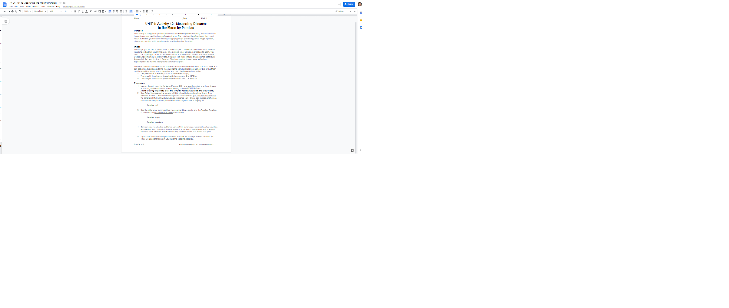
22. Activity 14—Measuring Distance to the Moon by Parallax

Now that students have some practice using parallax, they will use it for an astronomical calculation.

Apparatus
- SalsaJ or JS9
- Image file “U1Act14_Lunar Parallax 2004” installed on computers

Pre-activity discussion

Display image, “U1Act14_Lunar Parallax 2004” for the class. It is a composite (or superposition) of three images taken at the same instant from three different cities: Montreal (Canada), West Sussex (United Kingdom) and Montevideo (Uruguay).

The map in the upper right corner shows the three locations: A is Montreal; B is West Sussex; C is Montevideo. The Moon images are positioned as follows: A (lower left); B (lower right); C (upper). These images were taken during a lunar eclipse. The three original images were shifted so that the background stars were aligned.

Ask students to hypothesize about why they are seeing three different positions of the Moon

Give them copies of “Activity 14-Measuring Distance to the Moon by Parallax.” Have them discuss the differences between this activity and the Magnolia tree activity. (The main difference is that the students are using a composite image, so they can view and measure the parallax shift directly between two moon positions.)

Performance notes

Students have several options for measuring the parallax shift with the Straight Line Selection Tool. For example they could measure from one side of one moon to the corresponding side of the second moon. Or they can choose a reference star and measure from it to the two moons. Then subtract.

As is stated in the Instruction Sheet, a reasonable expectation for the final results are within about 10% of the published values. Pay attention to unit conversions.

Post-activity discussion
Students should whiteboard their findings, and share them at a board meeting. Encourage them to compare the methods they used for making the measurements, especially in regard to the parallax measurement on the composite image.
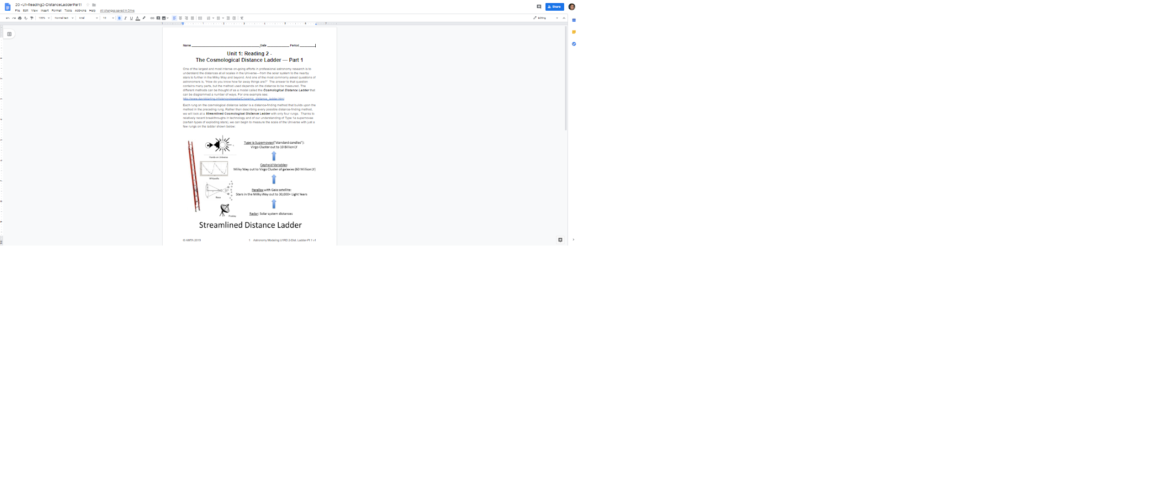

23. Reading 2—The Cosmic Distance Ladder - Part 1

Bu this time, students are probably wondering “How do astronomers really know how far away these objects we are looking at are?” Reading 2 introduces students to the concept of a Cosmological Distance Ladder, a diagrammatic representation of the sequence of methods or techniques used by astronomers to measure distances to astronomical objects. Each rung up the ladder represents a method for measuring larger and larger distances. Although the first rung represents the modern-day use of radar to determine relatively short distances, the second rung, that of parallax, was historically the first, and can be employed with relatively simple equipment.
Rather than describing every possible distance-finding method during the course, we will look at a Streamlined Cosmological Distance Ladder with only four rungs.

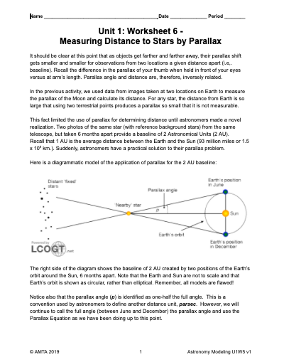
An excellent example of a cosmic distance ladder with informative links to details about each method and a wealth of information about astronomy is available from astronomer Dr. David Darling at: http://www.daviddarling.info/encyclopedia/C/cosmic_distance_ladder.html. This link is shared with students in the reading and teachers may find it useful to direct students to explore relevant links throughout the course.

24. Worksheet 6—Measuring Distance to Stars by Parallax

This worksheet gives practice with unit conversion and small angle approximation to calculate the distances to two stars using a baseline of 2 AU.

25. Activity 15—Practicum- Measuring the Distance to Asteroid 1998wt

This final practicum assesses students’ ability to use the measuring skills and tools they’ve developed.
Apparatus
- SalsaJ or JS9
- Folder of six mages installed on computers (“Asteroid 1998wt”-in Images for G1 folder)
- Printed copies of “U1Act13_2 pics asteroid 1998wt” (in “Images for G1” folder)
- Printed copies of “Activity 13-Measuring Distance to Asteroid 1998wt”
- Student notes from Activity 6 (Discover Asteroids), Activity 11 (Distance to Magnolia Tree), Activity 12 (Distance to Moon by Parallax), Worksheet 5 (Distance to Stars)

Performance Notes:
The asteroid they will be finding the distance to, named 1998wt, is the same one they investigated in Activity 6. The students will use images of this asteroid taken from two different telescopes in the US: Yerkes Observatory in southern Wisconsin and Gettysburg College Observatory in Pennsylvania.

They will be provided with the Plate Scales of the images and the baseline distance between the two observatories.

They have already had the experience of discovering the position of the asteroid in the Yerkes images in Activity 6 and they may have done the same with the Gettysburg image.Sincethat was a while ago, you may want to review that activity with them, creating an image stack in SalsaJ and turning on animation.

You may also want to review with them the process they used to determine the distance to a Magnolia Tree.

Once the students locate the asteroid in the two sets of images they will determine the parallax shift. They have two options to choose from, as shown on the “Activity 13-Measuring Distance to Asteroid 1998wt”. You could ask half the class to use Option 1 and the other half to use Option 2. Option 1 uses a technique very similar to that used in Activity 11-Distance to Magnolia by Parallax. Option 2 uses a technique somewhat similar to that used in the Moon measurement in Activity 12, although this one uses printed images rather than computer images. See below:
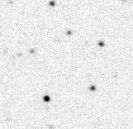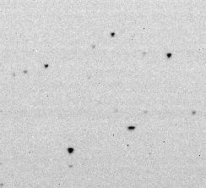
Gettysburg
Yerkes

When opening any of the six asteroid images, students need to pay attention to the time (0245, 0250, or 0255) and observatory:(g=Gettysburg and y=Yerkes) notations in the file names to ensure they are viewing the correct image.

Identifying a star pattern, particularly in the Gettysburg images, can be difficult. Encourage students to zoom the image sufficiently so that the stars are spread out.

This asteroid can be described as a near-Earth asteroid. Students’ final calculations of distance should be consistent with this. The published value for the distance to this asteroid is on the order of 0.2 AU.
Post-activity discussion
Have students share their results in a board meeting. Also ask them to discuss their thoughts about the location of this asteroid. Could it threaten the Earth? Why or why not?

Extensions
- Additional information about this asteroid and further information on parallax:
  - http://spiff.rit.edu/richmond/parallax/1998wt/par_1998wt.html.
- Reading on asteroid impacts.http://www.globalsystemsscience.org/studentbooks/acc/ch1
- Have students read “Optional Reading-Asteroid FAQ”, if they did not read it during Activity 6.

26. Quiz-Parallax

This quiz is designed to assess student understanding of the use of parallax to find distance, including small angle equation and parallax equation. Students also demonstrate application of dimensional analysis and correct use of units.

27. Activity 16 - What are these moving dots?

Show students a short video of the Galilean Moons orbiting the planet Jupiter where the moons appear just as bright dots in orbit YouTube link: https://youtu.be/Vo6FrMyK-3k.

It is very important not to call these objects the Galilean Moons of Jupiter, but simply as a “system of objects in motion.”

Discussion
Have students discuss in small groups what they think may be happening in the video, then come back together and share their groups’ hypotheses with the whole group.

Towards the end of the discussion project the painting below of 16th century Dominican Friar, Giordano Bruno, a leading philosopher of his time, and also a cosmological theorist. There are great video clips of his story in the first episode (“Standing Up in the Milky Way”) of the 2014 Fox Cosmos: A Spacetime Odyssey. You may also be able to find some clips online. Wait to show clips till after students make the connection between the video they saw and the notion that distant stars may also have planets around them.

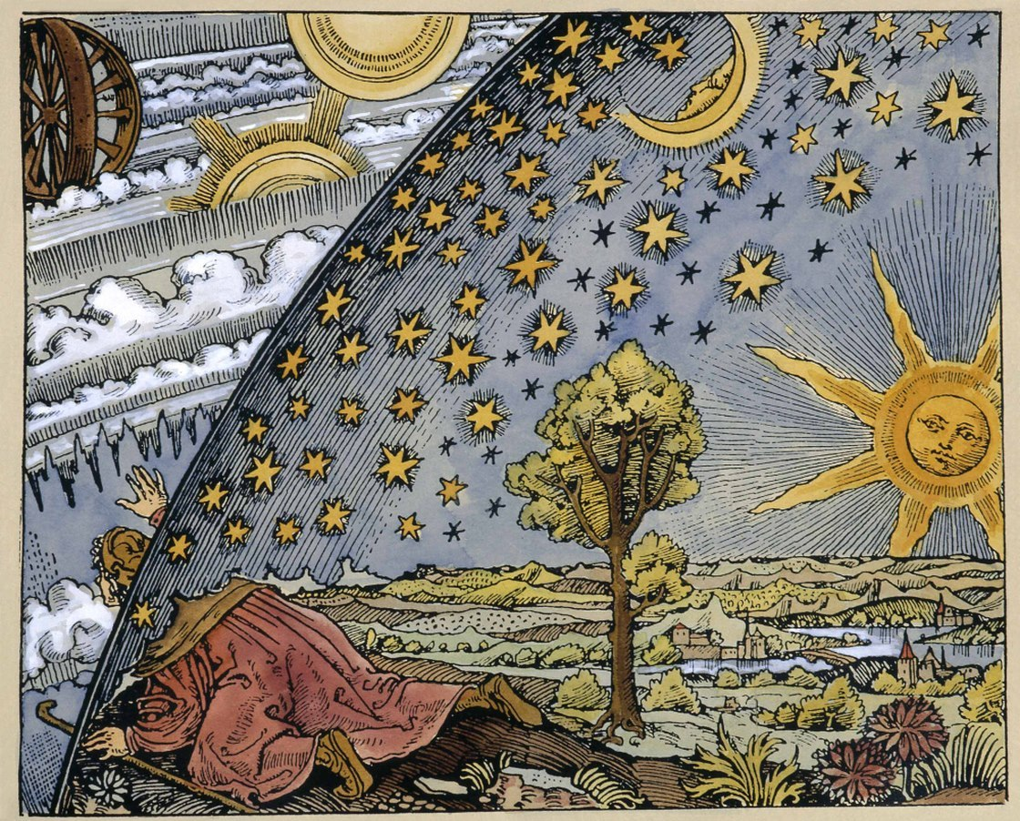

This discussion provides a bridge to unit 2 in which students will explore motion and the gravitational force that mediates interactions between massive objects in space such as those shown in the video.

